2ME3 Fall 2023 - Assignment 2
Test Cases Pdf Jasraj Johal johalj11

Test of Circle.intersect(Circle) (testCircleIntersectCircle)
Case 1

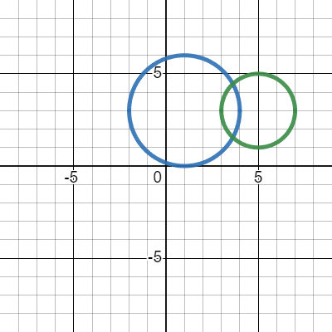
Circle c1 = new Circle(new Point(1.0f, 3.0f), 3.0f);
Circle c2 = new Circle(new Point(5.0f, 3.0f), 2.0f);
Expected Result: true
Code Result: true
Test Result: pass

Case 2

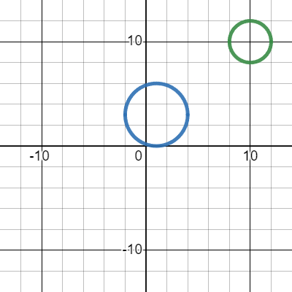
Circle c1 = new Circle(new Point(1.0f, 3.0f), 3.0f);
Circle c2 = new Circle(new Point(10.0f, 10.0f), 2.0f);
Expected Result: false
Code Result: false
Test Result: pass

Test of Circle.intersect(Rectangle) (testCircleIntersectRectangle)
Case 1

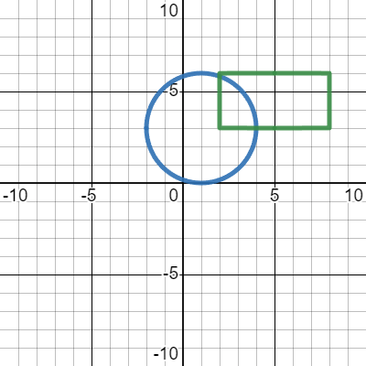
Circle c1 = new Circle(new Point(1.0f, 3.0f), 3.0f);
Rectangle r2 = new Rectangle(2.0f, 8.0f, 6.0f, 3.0f);
Expected Result: true
Code Result: true
Test Result: pass

Case 2

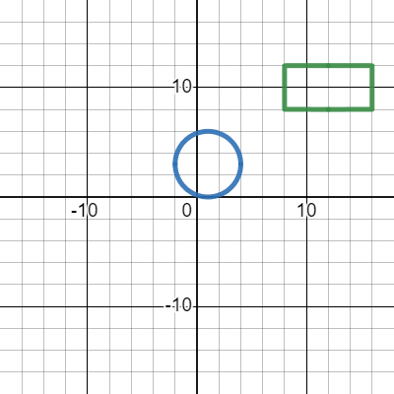
Circle c1 = new Circle(new Point(1.0f, 3.0f), 3.0f);
Rectangle r2 = new Rectangle(8.0f, 16.0f, 12.0f, 8.0f);
Expected Result: false
Code Result: false
Test Result: pass

Test of Circle.intersect(Point) (testCircleIntersectPoint)
Case 1

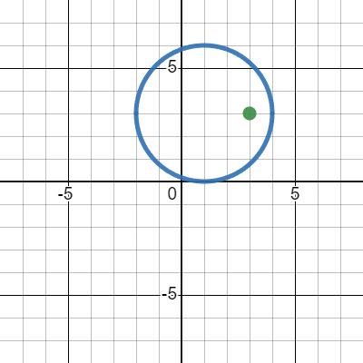
Circle c1 = new Circle(new Point(1.0f, 3.0f), 3.0f);
Point p2 = new Point(3.0f, 3.0f);
Expected Result: true
Code Result: true
Test Result: pass

Case 2

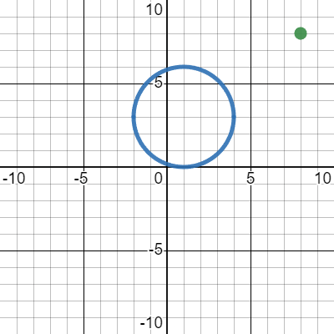
Circle c1 = new Circle(new Point(1.0f, 3.0f), 3.0f);
Point p2 = new Point(8.0f, 8.0f);
Expected Result: false
Code Result: false
Test Result: pass

Test of Circle.intersect(LineSeg) (testCircleIntersectLineSeg)
Case 1

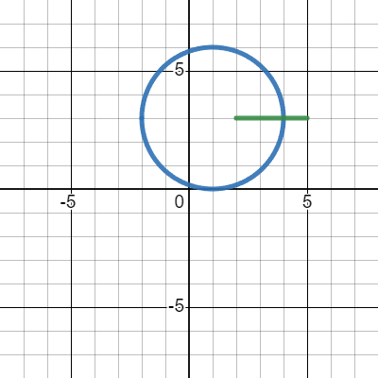
Circle c1 = new Circle(new Point(1.0f, 3.0f), 3.0f);
LineSeg l2 = new LineSeg(new Point(2.0f, 3.0f), new Point(5.0f, 3.0f));
Expected Result: true
Code Result: true
Test Result: pass

Case 2

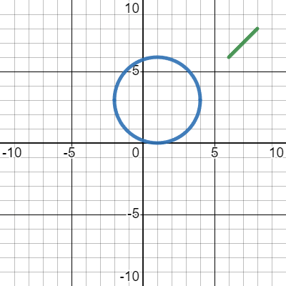
Circle c1 = new Circle(new Point(1.0f, 3.0f), 3.0f);
LineSeg l2 = new LineSeg(new Point(6.0f, 6.0f), new Point(8.0f, 8.0f));
Expected Result: false
Code Result: false
Test Result: pass

Test of Point.intersect(Circle) (testPointIntersectCircle)
Case 1

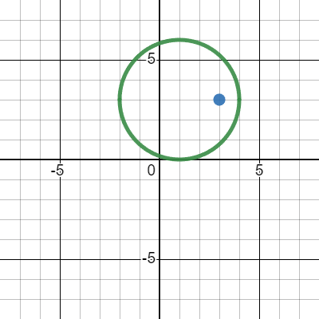
Point p1 = new Point(3.0f, 3.0f);
Circle c2 = new Circle(new Point(1.0f, 3.0f), 3.0f);
Expected Result: true
Code Result: true
Test Result: pass

Case 2

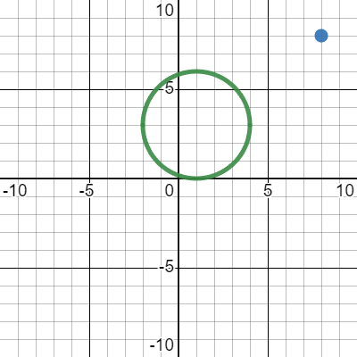
Point p1 = new Point(8.0f, 8.0f);
Circle c2 = new Circle(new Point(1.0f, 3.0f), 3.0f);
Expected Result: false
Code Result: false
Test Result: pass

Test of Point.intersect(Rectangle) (testPointIntersectRectangle)
Case 1

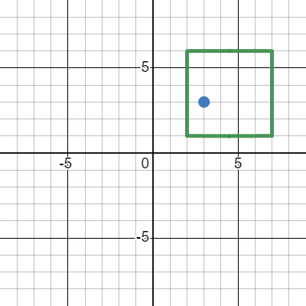
Point p1 = new Point(3.0f, 3.0f);
Rectangle r2 = new Rectangle(2.0f, 7.0f, 6.0f, 1.0f);
Expected Result: true
Code Result: true
Test Result: pass

Case 2

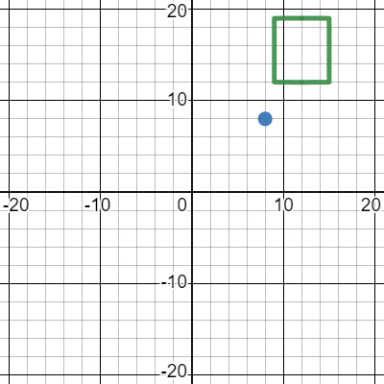
Point p1 = new Point(8.0f, 8.0f);
Rectangle r2 = new Rectangle(9.0f, 15.0f, 19.0f, 12.0f);
Expected Result: false
Code Result: false
Test Result: pass

Test of Point.intersect(Point) (testPointIntersectPoint)
Case 1

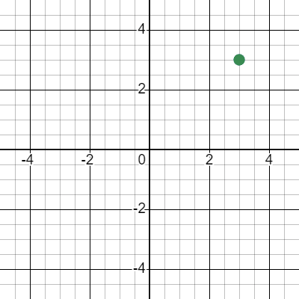
Point p1 = new Point(3.0f, 3.0f);
Point p2 = new Point(3.0f, 3.0f);
Expected Result: true
Code Result: true
Test Result: pass

Case 2

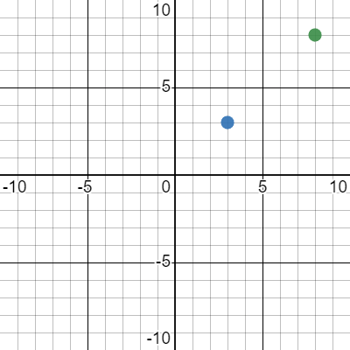
Point p1 = new Point(3.0f, 3.0f);
Point p2 = new Point(8.0f, 8.0f);
Expected Result: false
Code Result: false
Test Result: pass

Test of Point.intersect(LineSeg) (testPointIntersectLineSeg)
Case 1

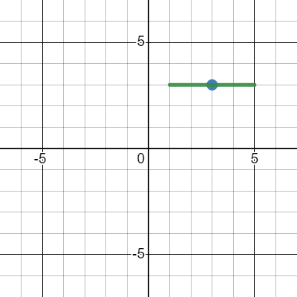
Point p1 = new Point(3.0f, 3.0f);
LineSeg l2 = new LineSeg(new Point(1.0f, 3.0f), new Point(5.0f, 3.0f));
Expected Result: true
Code Result: true
Test Result: pass

Case 2

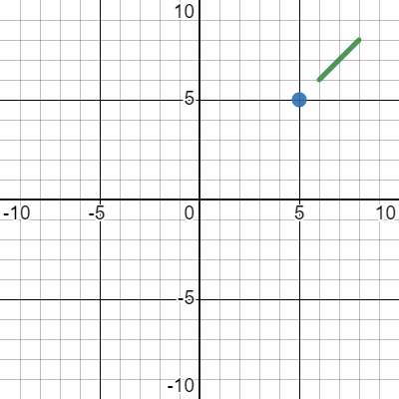
Point p1 = new Point(5.0f, 5.0f);
LineSeg l2 = new LineSeg(new Point(6.0f, 6.0f), new Point(8.0f, 8.0f));
Expected Result: false
Code Result: false
Test Result: pass

Test of Rectangle.intersect(Rectangle) (testRectangleIntersectRectangle)
Case 1

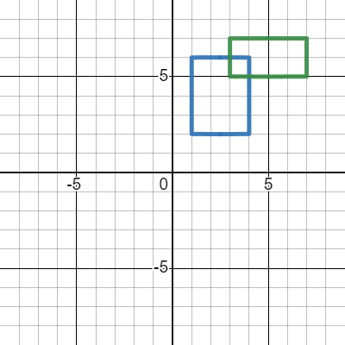
Rectangle r1 = new Rectangle(1.0f, 4.0f, 6.0f, 2.0f);
Rectangle r2 = new Rectangle(3.0f, 7.0f, 7.0f, 5.0f);
Expected Result: true
Code Result: true
Test Result: pass

Case 2

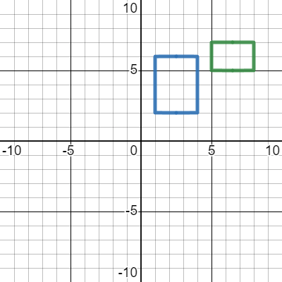
Rectangle r1 = new Rectangle(1.0f, 4.0f, 6.0f, 2.0f);
Rectangle r2 = new Rectangle(5.0f, 8.0f, 7.0f, 5.0f);
Expected Result: false
Code Result: false
Test Result: pass

Test of Rectangle.intersect(Circle) (testRectangleIntersectCircle)
Case 1

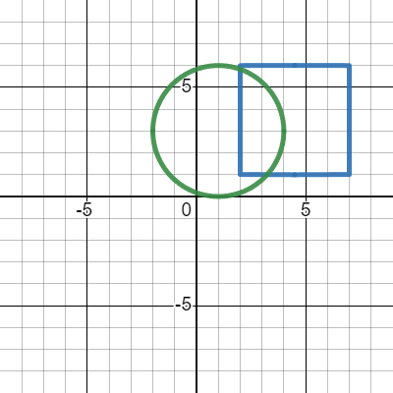
Rectangle r1 = new Rectangle(2.0f, 7.0f, 6.0f, 1.0f);
Circle c2 = new Circle(new Point(1.0f, 3.0f), 3.0f);
Expected Result: true
Code Result: true
Test Result: pass

Case 2

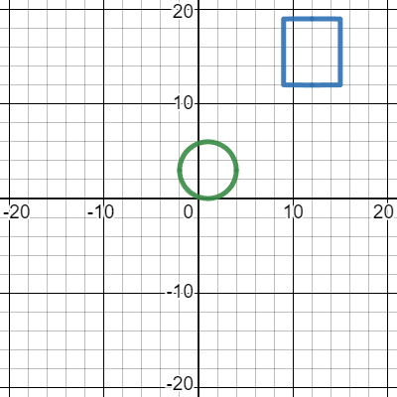
Rectangle r1 = new Rectangle(9.0f, 15.0f, 19.0f, 12.0f);
Circle c2 = new Circle(new Point(1.0f, 3.0f), 3.0f);
Expected Result: false
Code Result: false
Test Result: pass

Test of Rectangle.intersect(Point) (testRectangleIntersectPoint)
Case 1

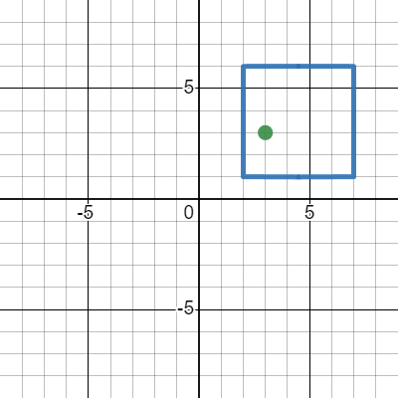
Rectangle r1 = new Rectangle(2.0f, 7.0f, 6.0f, 1.0f);
Point p2 = new Point(3.0f, 3.0f);
Expected Result: true
Code Result: true
Test Result: pass

Case 2

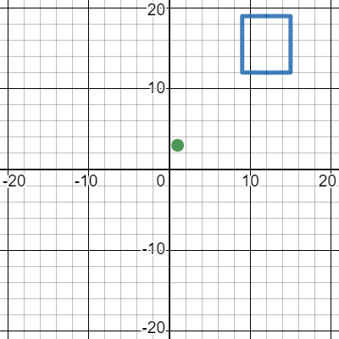
Rectangle r1 = new Rectangle(9.0f, 15.0f, 19.0f, 12.0f);
Point p2 = new Point(1.0f, 3.0f);
Expected Result: false
Code Result: false
Test Result: pass

Test of Rectangle.intersect(LineSeg) (testRectangleIntersectLineSeg)
Case 1

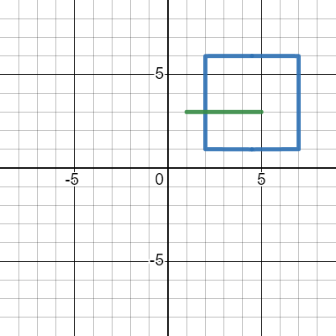
Rectangle r1 = new Rectangle(2.0f, 7.0f, 6.0f, 1.0f);
LineSeg l2 = new LineSeg(new Point(1.0f, 3.0f), new Point(5.0f, 3.0f));
Expected Result: true
Code Result: true
Test Result: pass

Case 2

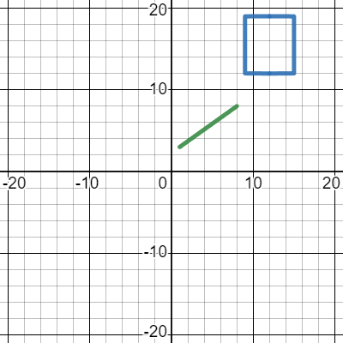
Rectangle r1 = new Rectangle(9.0f, 15.0f, 19.0f, 12.0f);
LineSeg l2 = new LineSeg(new Point(1.0f, 3.0f), new Point(8.0f, 8.0f));
Expected Result: false
Code Result: false
Test Result: pass

Test of LineSeg.intersect(Circle) (testLineSegIntersectCircle)
Case 1

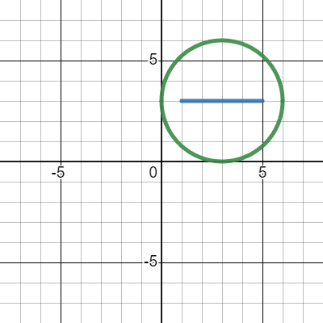
LineSeg l1 = new LineSeg(new Point(1.0f, 3.0f), new Point(5.0f, 3.0f));
Circle c2 = new Circle(new Point(3.0f, 3.0f), 3.0f);
Expected Result: true
Code Result: true
Test Result: pass

Case 2

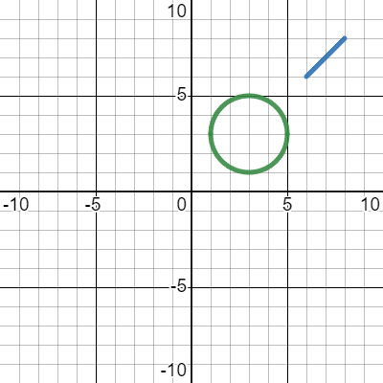
LineSeg l1 = new LineSeg(new Point(6.0f, 6.0f), new Point(8.0f, 8.0f));
Circle c2 = new Circle(new Point(3.0f, 3.0f), 2.0f);
Expected Result: false
Code Result: false
Test Result: pass

Test of LineSeg.intersect(Point) (testLineSegIntersectPoint)
Case 1

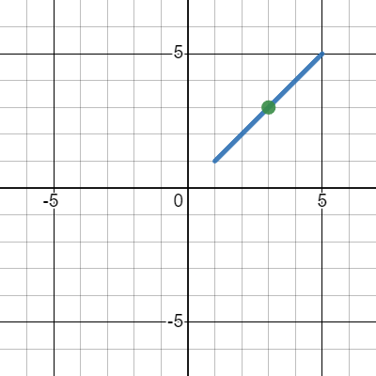
LineSeg l1 = new LineSeg(new Point(1.0f, 1.0f), new Point(5.0f, 5.0f));
Point p2 = new Point(3.0f, 3.0f);
Expected Result: true
Code Result: true
Test Result: pass

Case 2

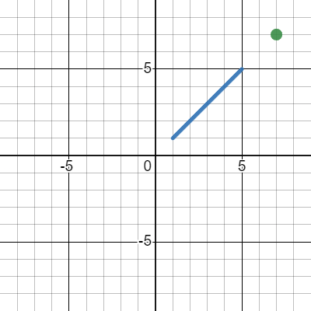
LineSeg l1 = new LineSeg(new Point(1.0f, 1.0f), new Point(5.0f, 5.0f));
Point p2 = new Point(7.0f, 7.0f);
Expected Result: false
Code Result: false
Test Result: pass

Test of LineSeg.intersect(Rectangle) (testLineSegIntersectRectangle)
Case 1

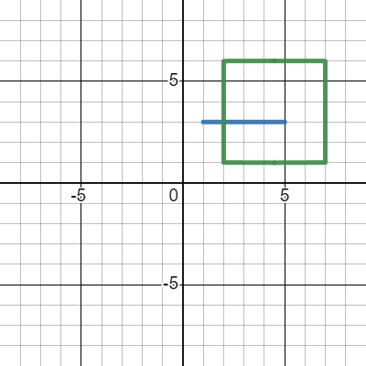
LineSeg l1 = new LineSeg(new Point(1.0f, 3.0f), new Point(5.0f, 3.0f));
Rectangle r2 = new Rectangle(2.0f, 7.0f, 6.0f, 1.0f);
Expected Result: true
Code Result: true
Test Result: pass

Case 2

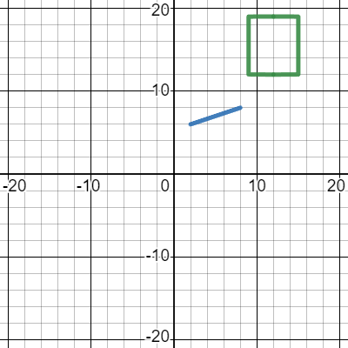
LineSeg l1 = new LineSeg(new Point(2.0f, 6.0f), new Point(8.0f, 8.0f));
Rectangle r2 = new Rectangle(9.0f, 15.0f, 19.0f, 12.0f);
Expected Result: false
Code Result: false
Test Result: pass

Test of LineSeg.intersect(LineSeg) (testLineSegIntersectLineSeg)
Case 1

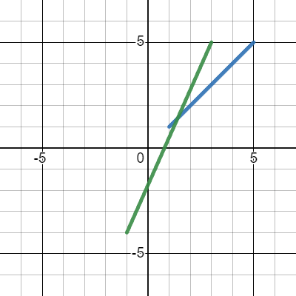
LineSeg l1 = new LineSeg(new Point(1.0f, 1.0f), new Point(5.0f, 5.0f));
LineSeg l2 = new LineSeg(new Point(-1.0f, -4.0f), new Point(3.0f, 5.0f));
Expected Result: true
Code Result: true
Test Result: pass

Case 2

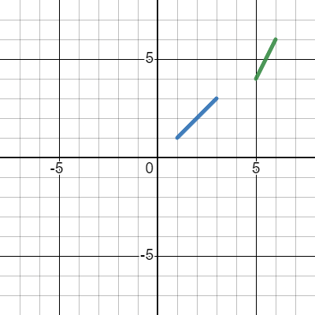
LineSeg l1 = new LineSeg(new Point(1.0f, 1.0f), new Point(3.0f, 3.0f));
LineSeg l2 = new LineSeg(new Point(5.0f, 4.0f), new Point(6.0f, 6.0f));
Expected Result: false
Code Result: false
Test Result: pass

