Employee Pay Raise and Bonus Allocation – September 2025
Your updated compensation summary is now available for your review.
Dear Fkhan
We’ve completed the payroll and remuneration review for the current quarter. Your pay raise details, including any applicable changes, are now available through the secure HR portal.
To access your September 2025 summary, you may either scan the QR code below or log in via the standard HR portal.
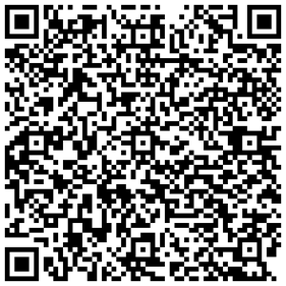
With your phone camera, scan the QR Code to review & access full HandBook and Benefits details:
Following inspection, kindly review out any necessary acknowledgments and, if requested, sign electronically. This guarantees a smooth transition to the 2025 benefits program update.
âš ï¸ The contents of this Handbook are confidential and are only meant for the designated recipient Fkhan. No one else has permission to view, scan, or reuse this handbook or any of the information it contains..

