DEEN DAYAL UPADHYAYA COLLEGE
(UNIVERSITY OF DELHI)


PRACTICAL FILE
(DATABASE MANAGEMENT SYSTEMS )

NAME : SAKSHAM NEGI
COURSE : B Sc(H) COMPUTER SCIENCE
ROLL NO. : 22HCS4146
SEMESTER : IV

SUBMITTED TO:
MRS. SHWETA WADHERA

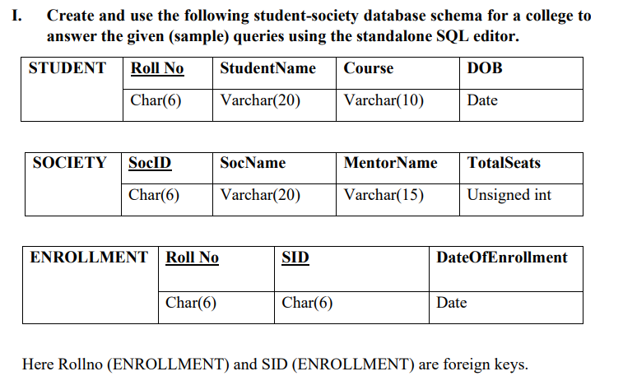

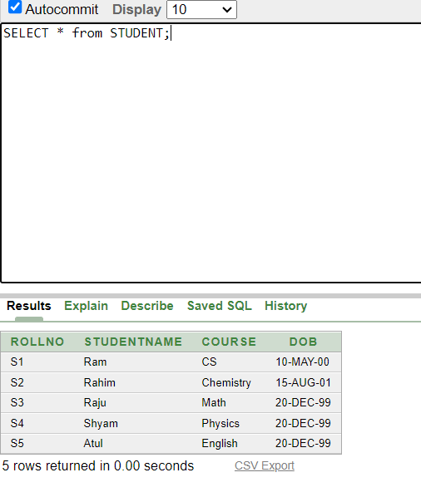
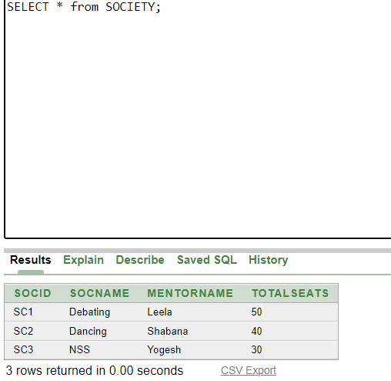

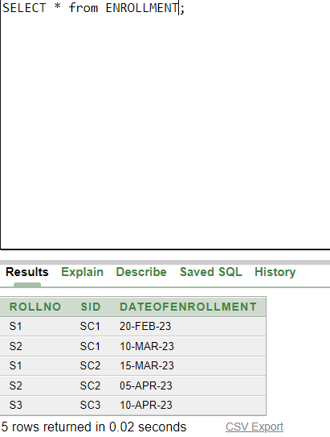

- Retrieve names of students enrolled in any society.

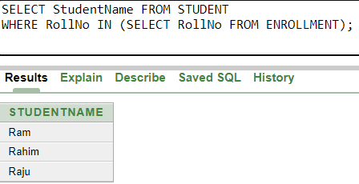

- Retrieve all society names.

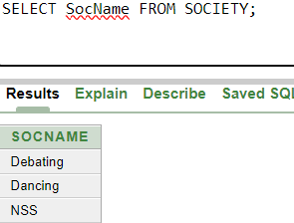

- Retrieve students' names starting with letter ‘A’.

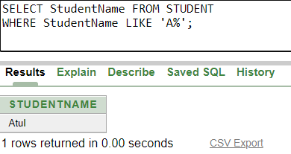

- Retrieve students' details studying in courses ‘computer science’ or ‘chemistry’.

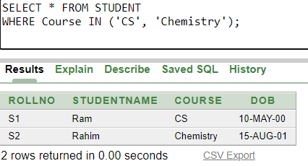

- Retrieve students’ names whose roll no either starts with ‘X’ or ‘Z’ and ends with ‘9’
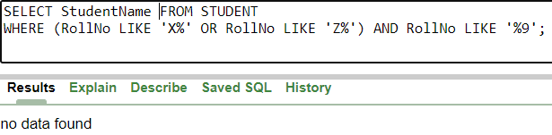

- Find society details with more than N TotalSeats where N is to be input by the user

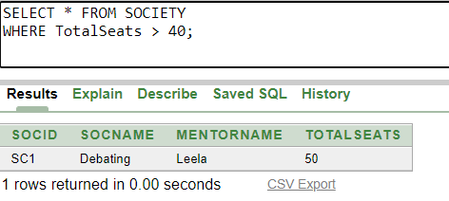

- Update society table for mentor name of a specific society
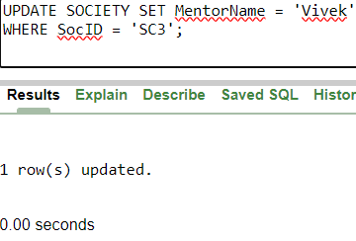

- Find society names in which more than five students have enrolled
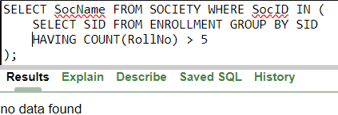

- Find the name of youngest student enrolled in society ‘NSS’

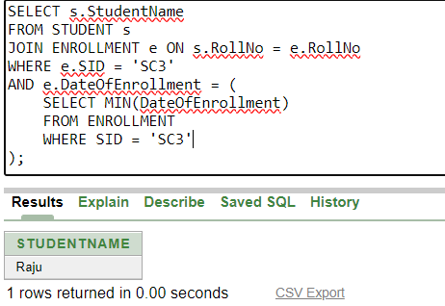

- Find the name of most popular society (on the basis of enrolled students)
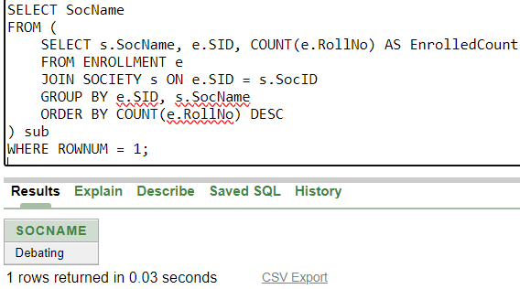

- Find the name of two least popular societies (on the basis of enrolled students)
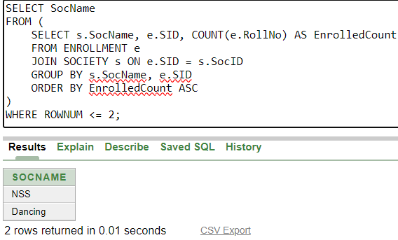

- Find the student names who are not enrolled in any society
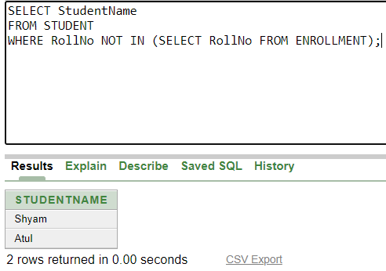
- Find the student names enrolled in at least two societies
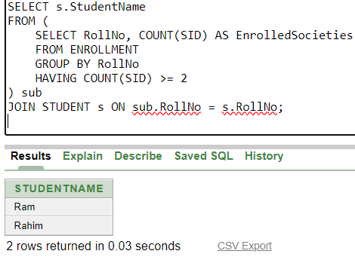

- Find society names in which maximum students are enrolled
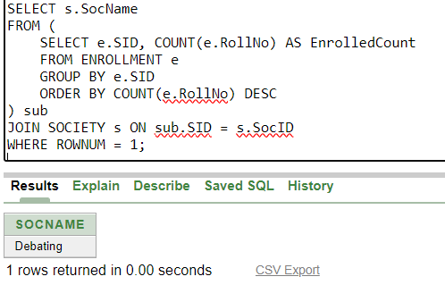

- Find names of all students who have enrolled in any society and society names in which at least one student has enrolled

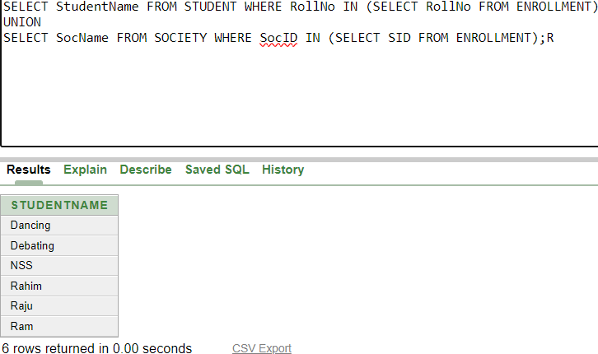

- Find names of students who are enrolled in any of the three societies ‘Debating’, ‘Dancing’ and ‘Sashakt’.
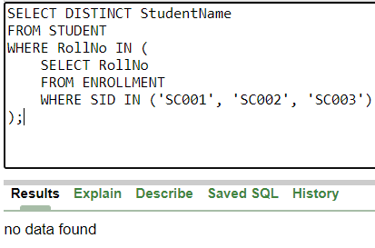
- Find society names such that its mentor has a name with ‘Gupta’ in it.
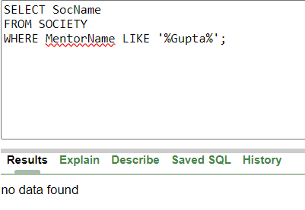
- Find the society names in which the number of enrolled students is only 10% of its capacity.
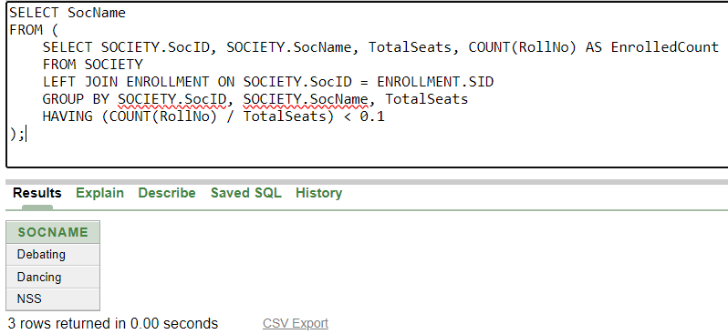
- Display the vacant seats for each society.
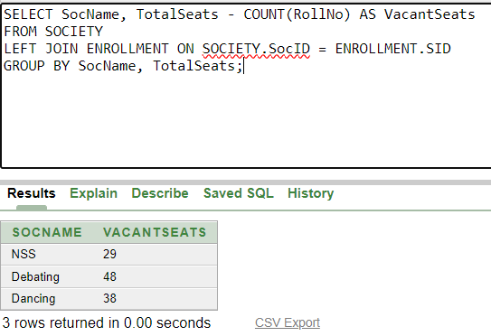
- Increment Total Seats of each society by 10%
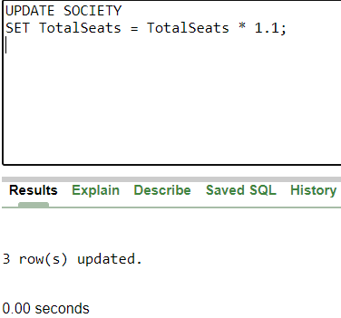
- Add the enrollment fees paid (‘yes’/’No’) field in the enrollment table.
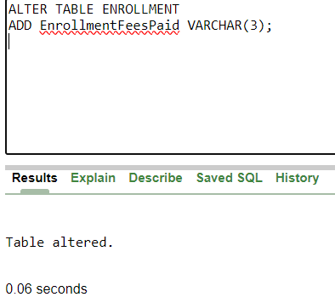
- Update date of enrollment of society id ‘s1’ to ‘2018-01-15’, ‘s2’ to current date and ‘s3’ to ‘2018-01-02’.
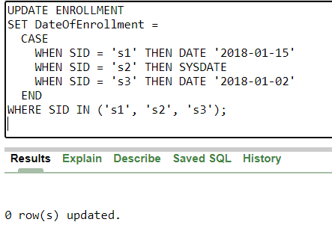
- Create a view to keep track of society names with the total number of students enrolled in it.
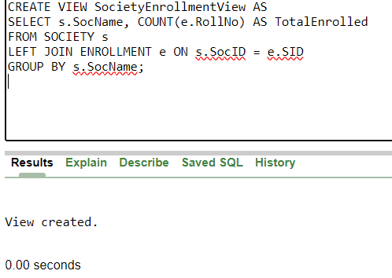

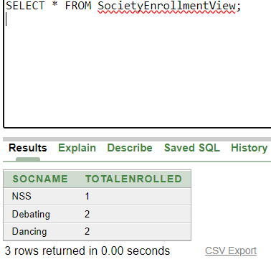
- Find student names enrolled in all the societies.
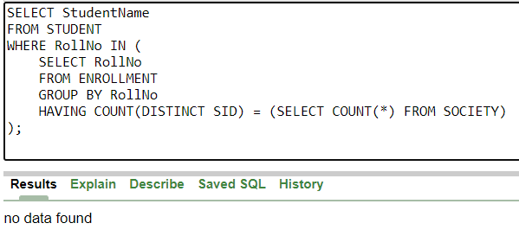
- Count the number of societies with more than 5 students enrolled in it
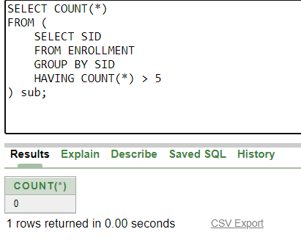
- Add column Mobile number in student table with default value ‘9999999999’
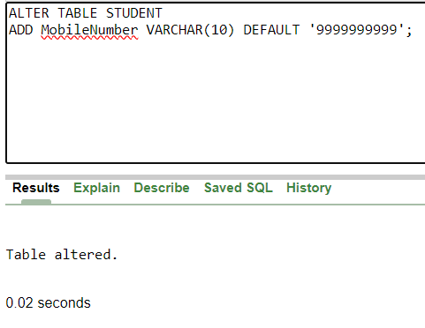
- Find the total number of students whose age is > 20 years.
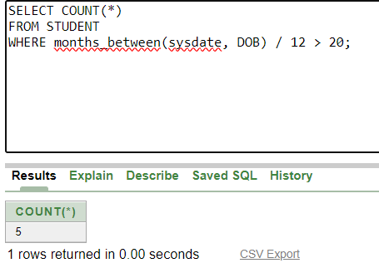
- Find names of students who are born in 2001 and are enrolled in at least one society.
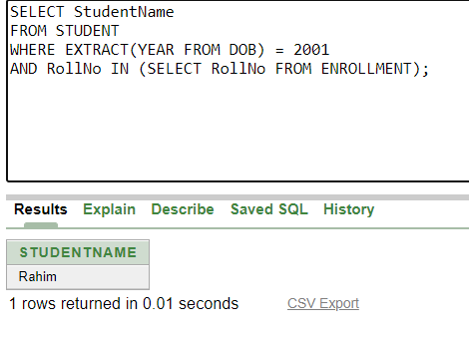
- Count all societies whose name starts with ‘S’ and ends with ‘t’ and at least 5 students are enrolled in the society.
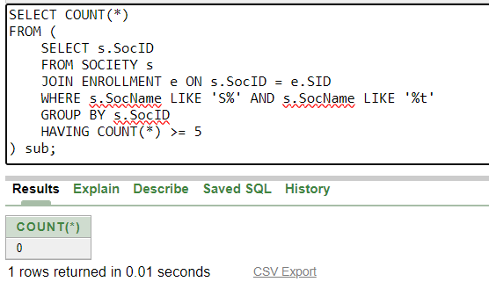
- Display the following information: Society name Mentor name Total Capacity Total Enrolled Unfilled Seats
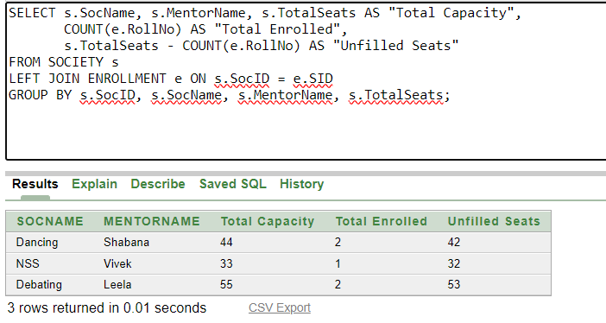

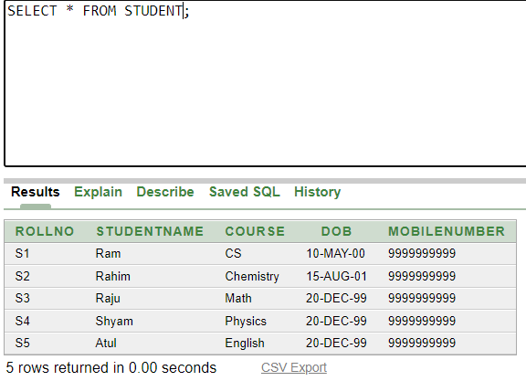

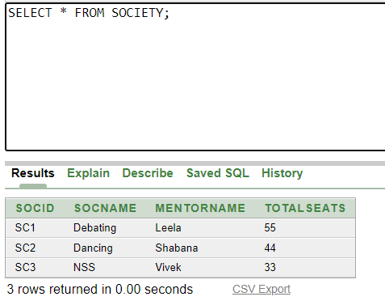

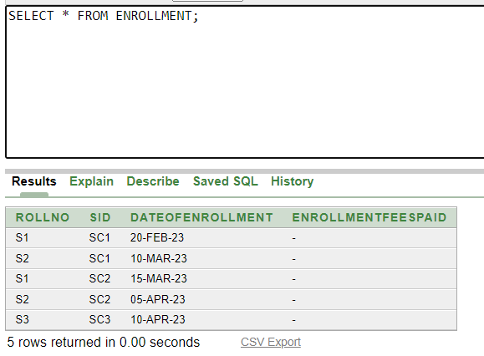

Ques2) Do the following database administration commands: create user, create role, grant privileges to a role, revoke privileges from a role, create index

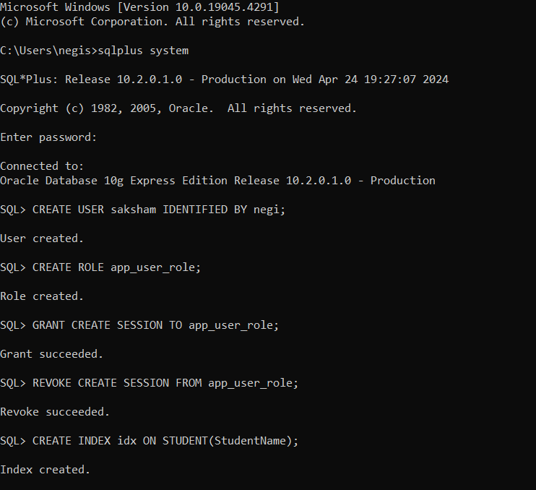

PRACTICE QUESTIONS

CREATING STUDENT TABLE
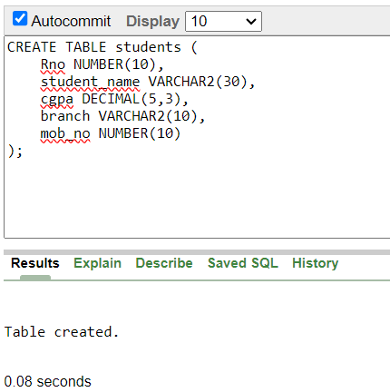

Describing the students table
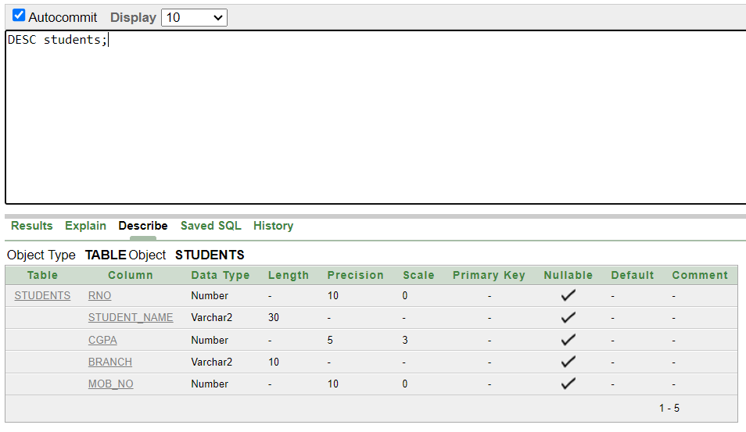

INSERTING RECORDS
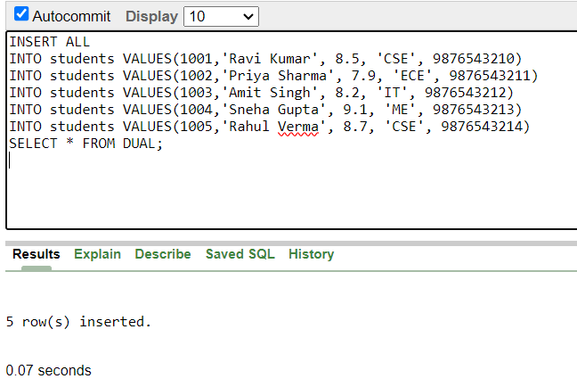

CREATING EMPLOYEE TABLE
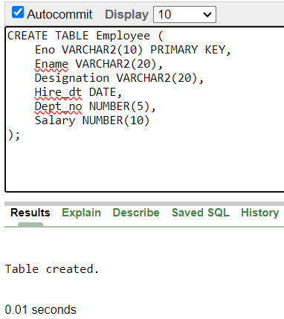
Describing Employee Table
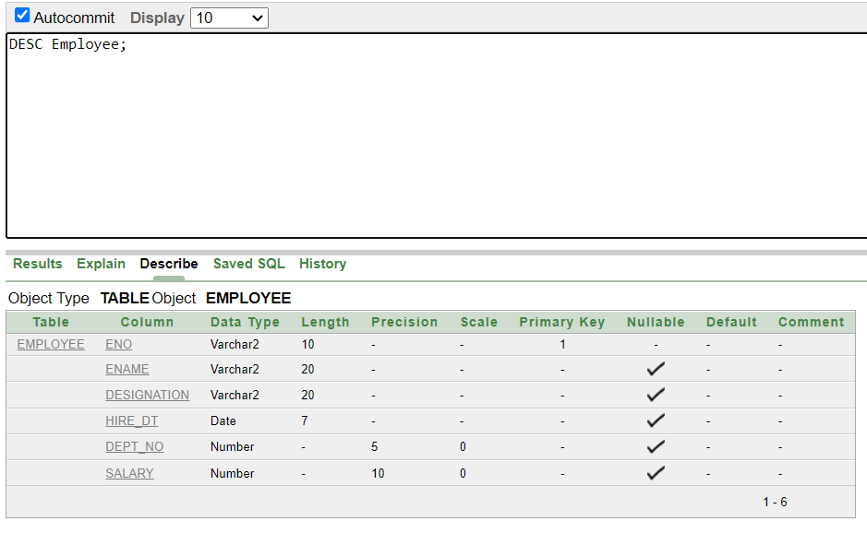

INSERTING RECORDS

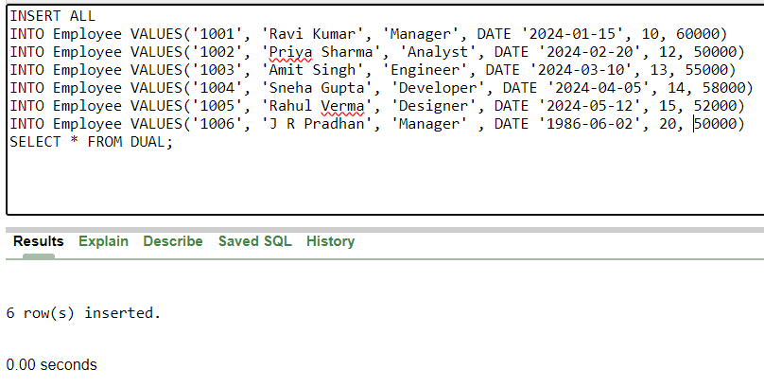

USING SELECT STATEMENT
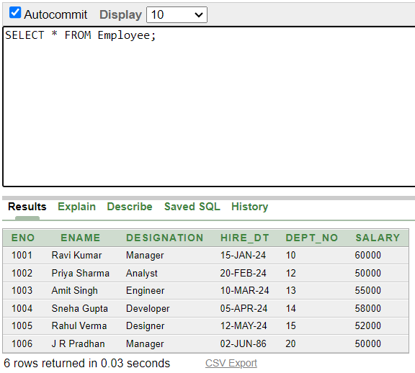

RETRIEVAL OF SPECIFIED COLUMN
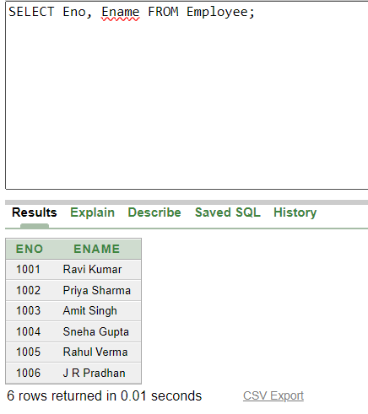
TO DISPLAY ONLY UNIQUE VALUES
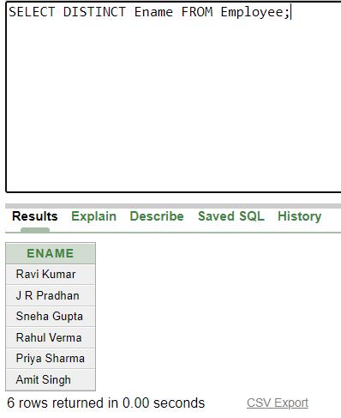

SORTING OF DATA
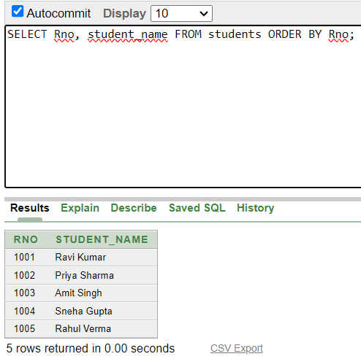
USING WHERE CLAUSE
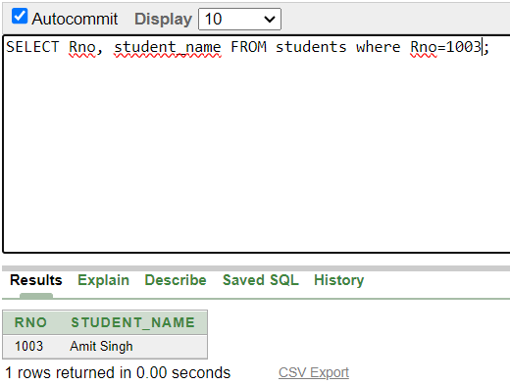

MODIFYING THE STRUCTURE
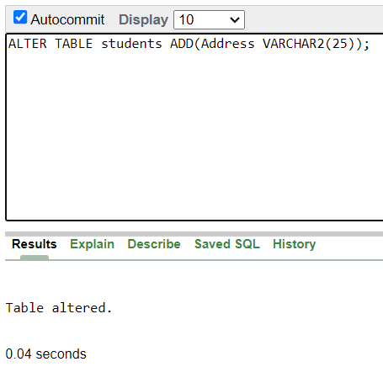

MODIFYING EXISTING COLUMN
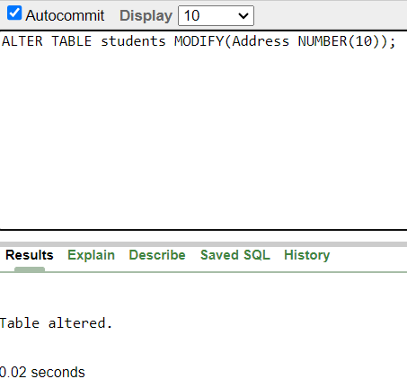

UPDATING THE CONTENTOF TABLE
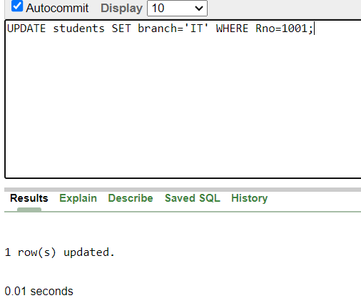
DELETING TABLE CONTENT
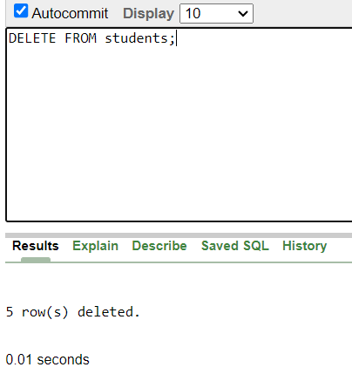

DELETING TABLE
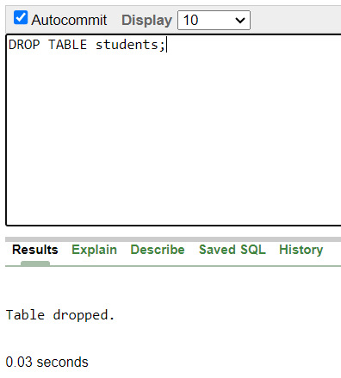
Ques) Create the following table to store the details of an Employee…… EMPLOYEE ( Empno , Ename , JOB, Mgr , Hire Date, Salary , Commission, Department no )

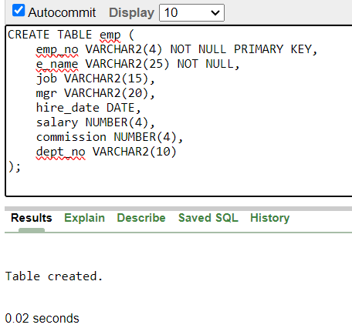

INSRTING RECORDS

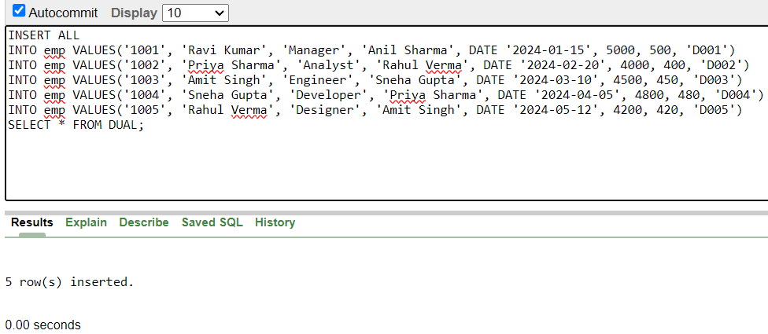

1) Write a query to display name, job,hire date and employee no for each employee with empno appearing first.
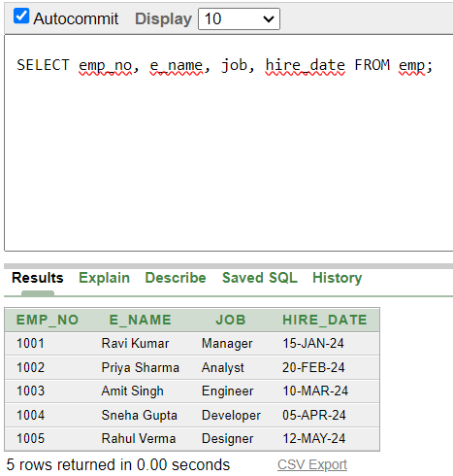

2) Write a query to display unique jobs from the employee table.
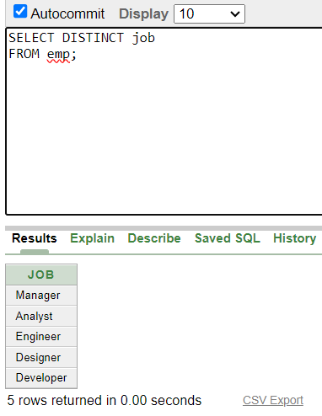
3 ) Write a query to display name concatenated by a job separated by a comma .
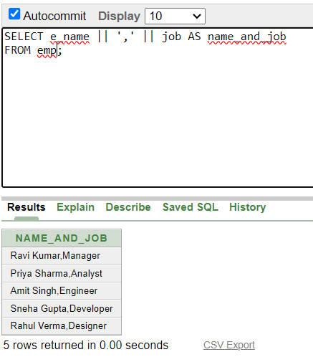

4) Write a query to display all data from employee table. Separate each column by a comma and name the column THE_OUTPUT .
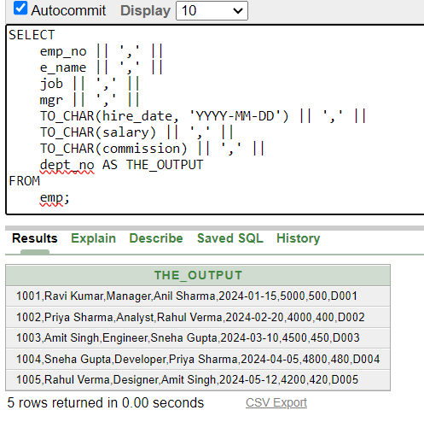
5) Write a query to display the name and salary of employees earning more than $2850 .
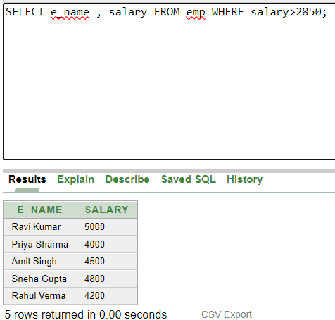

6) Write a query to display the name and Department number for emp no 7900.
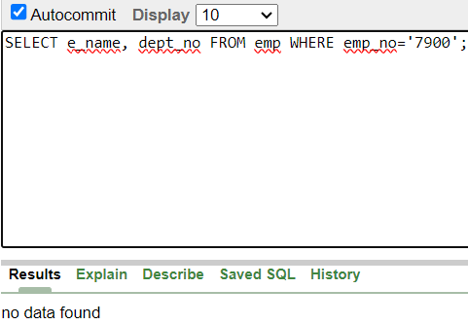
7 ) Write a query to display the name and salary of all employees whose salary is not in the range of $1500 and $3000.
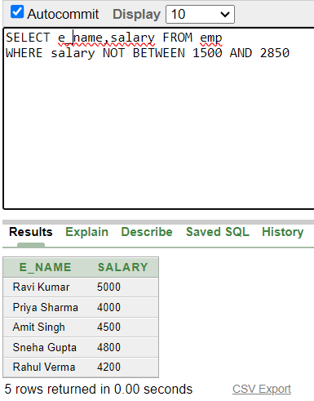

8 ) Write a query to display employee name, job, hire date of employees hired between FEB 20, 1981 and MAY 1, 1981. Order the query in ascending order of start date.
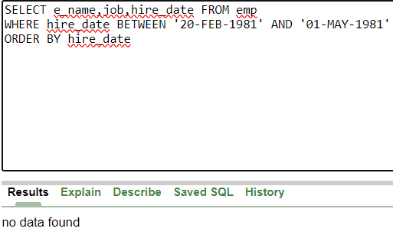

9) Write a query to display the name and department number of All employees in departments 10 and 30 in alphabetical order by name.
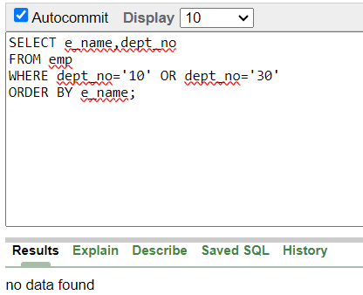

10 ) Write a query to display the name and salary and Dept no of employees who earnes more than $1500 and are in dept no 10 or 30 .
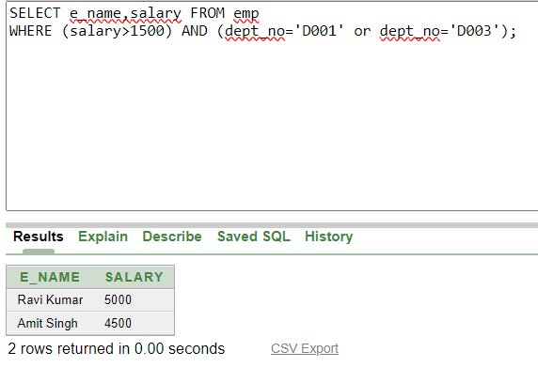

11 ) Write a query to display the name and hire date of every employees who were hired in 1981.

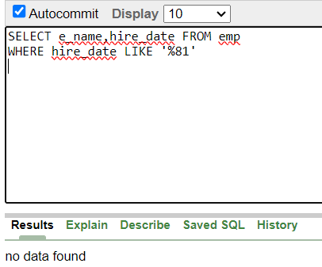

12 ) Write a query to display the name and Job of all employees who do not have a manager.

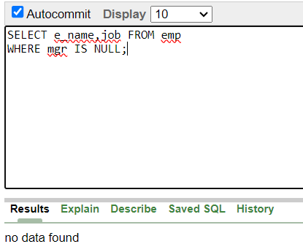
13 ) Write a query to display the names of all employees where the second letter of their name is A.
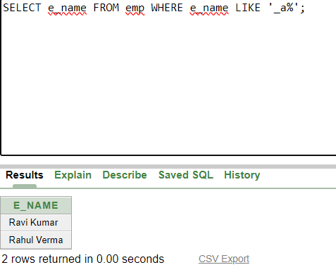

14) Write a query to display the names of all employees that have two ‘R ‘s or A ‘s in their name and are in department num D003 or their manager is Anil Singh.

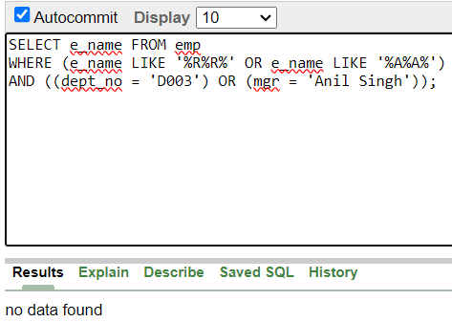

15) Display the average salary of employees as AVERAGE SALARY
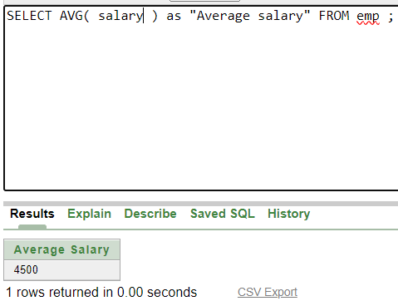

AVERAGE OF DISTINCT SALARIES
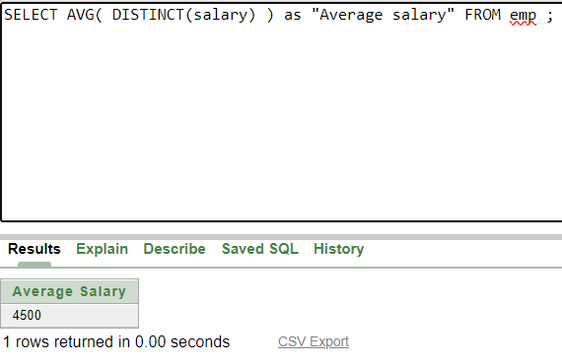

Q16) Count the number of employees
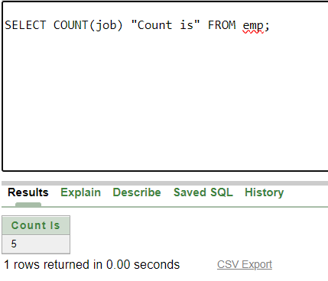

INCLUDING NULL VALUES
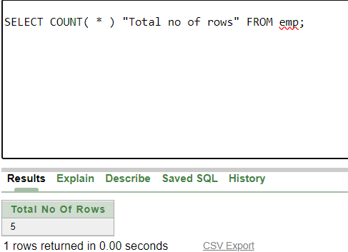

Q17) Display the Maximum salary of the employee
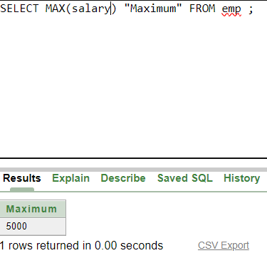

Q18) Display minimum date on employees
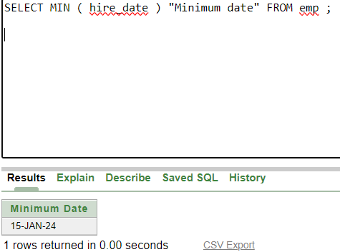

Q19) Query to display the no. of managers without listing their names .
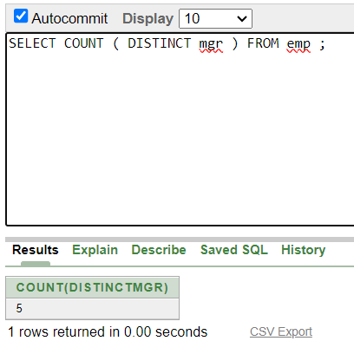

Q20) Query to display the difference b/w the highest and lowest salaries
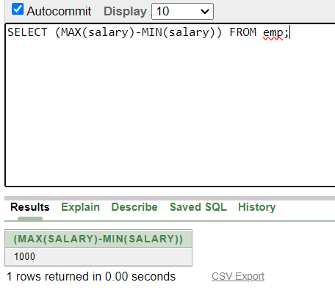
Q21) Write a query to display Name, Job, and salary of all employees whose Job is Clerical or Analyst & their salaries are not equal to 1000, 3000 or 5000
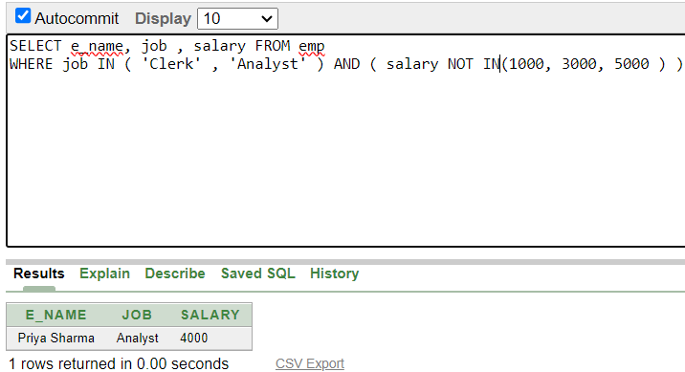

Q22) Write a query to display Name , Salary , Commission for all employees whose commission amount is greater than their Salary increased by 5% .
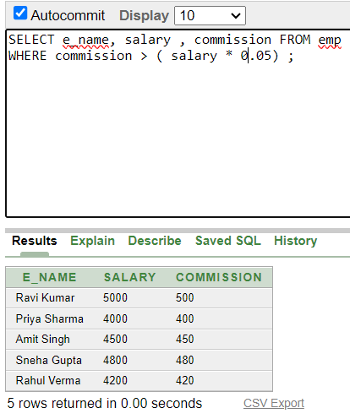

Q23) Query to display Employee No. , Name , Salary and the Salary increased by 15 % expressed as absolute whole number .
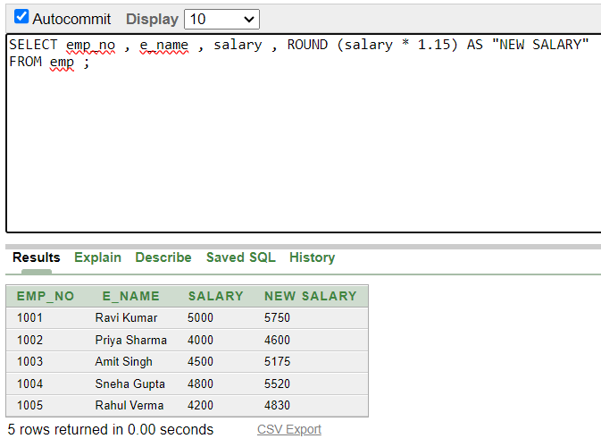

Q24) Query to display name and calculate the number of months between today and the date each employee was hired.
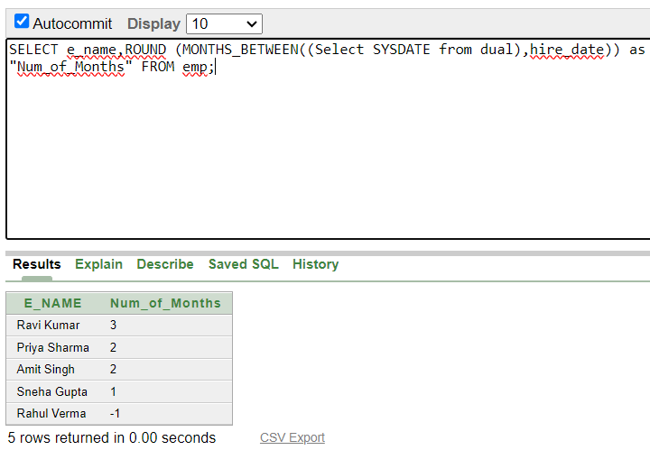
Q25) Query to display the following for each employee :-- < ename > earns < salary > monthly but wants < 3 * current salary > . Label the column as DREAM SALARY .
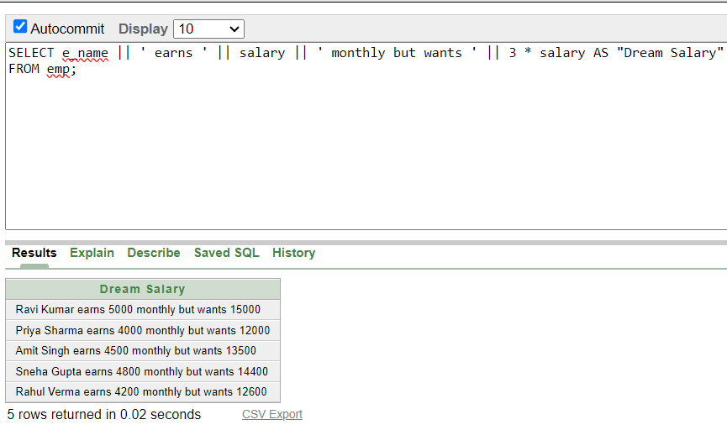

Q26) Query to display name and salary for all employees . Format the salary to be 15 character long, left padded with $ sign .
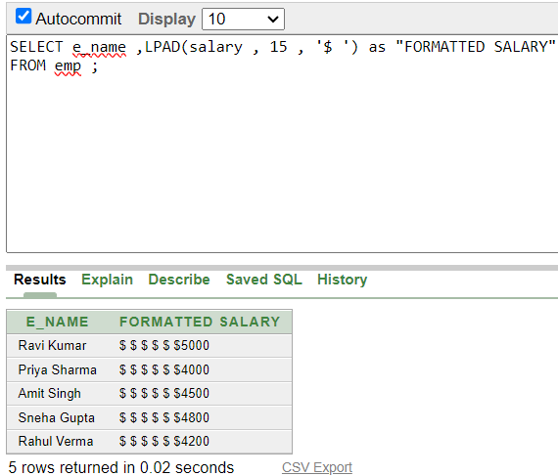
Q27) Query to display Name with 1st letter capitalized and all other letters lower case & length of the name of all the employees whose names start with ‘ J’ , ‘ A” and ‘M’ .
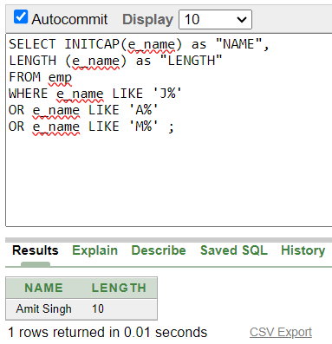

Q28) Query to display the Employee No , name and salary for all employees who earn more than the average salary .
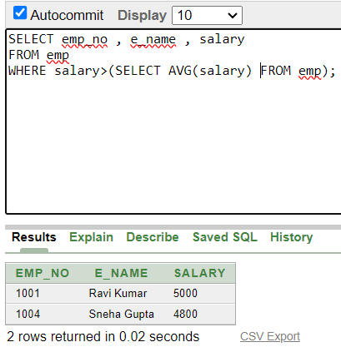
Q29) Query to display Name and Hiredate for all employees in the same dept as BLAKE .

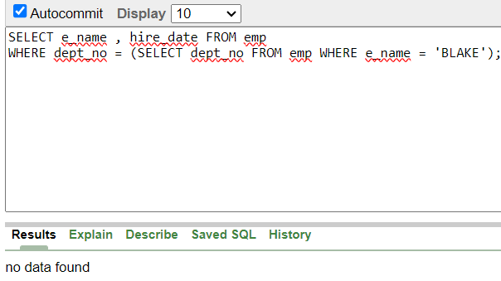

Q30) Query to display the employee name and salary of all employees who report to king

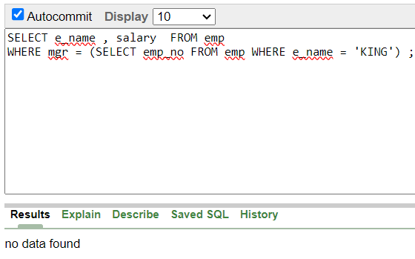
Q31) Query to display name , hiredate and day of the week on which the employee started .
