Assignment 2

Jasraj Singh Johal | 400434346 | johalj11

Question 1: Big Θ Proofs Using only the formal definition of Big O, Big Omega, and Big Theta, prove the following. You do not have to show any pre-proof analysis, but make sure that you justify every step in the proof.

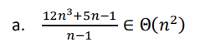
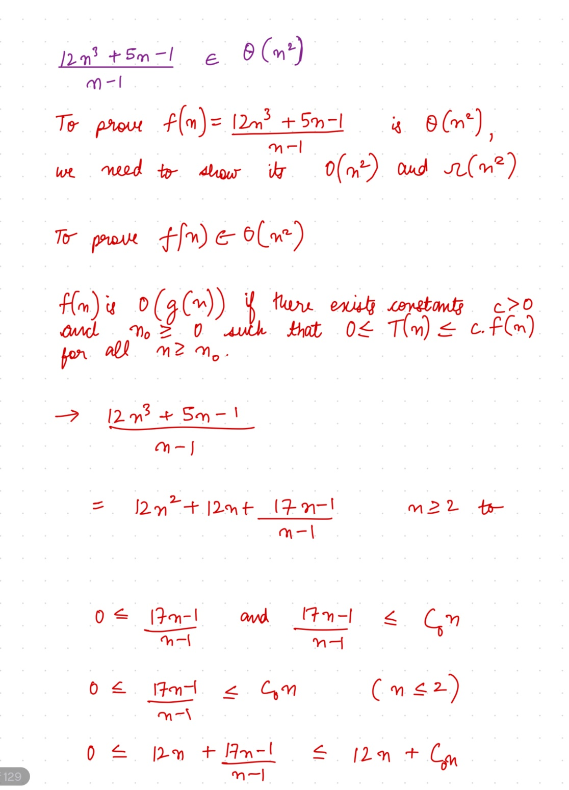

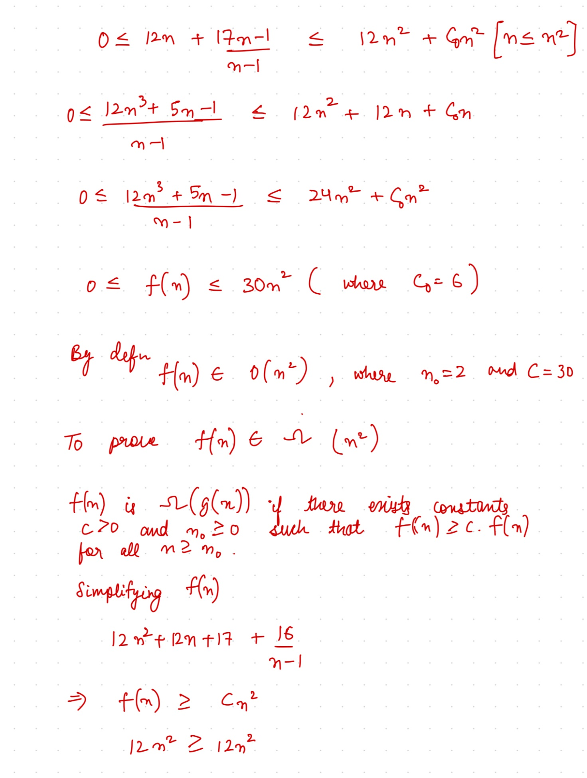

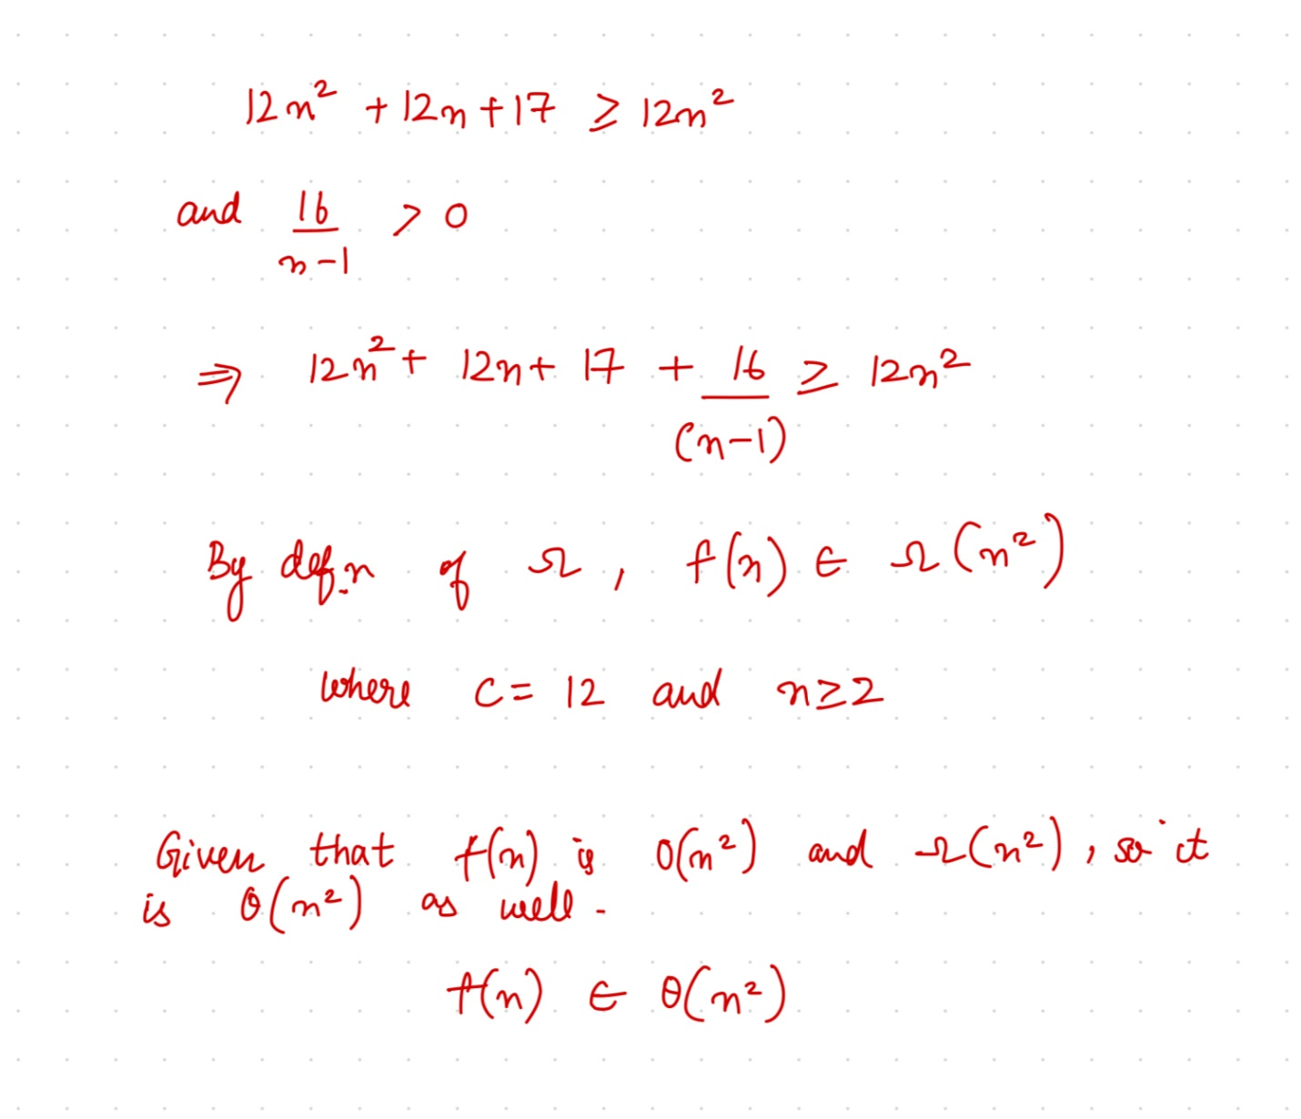

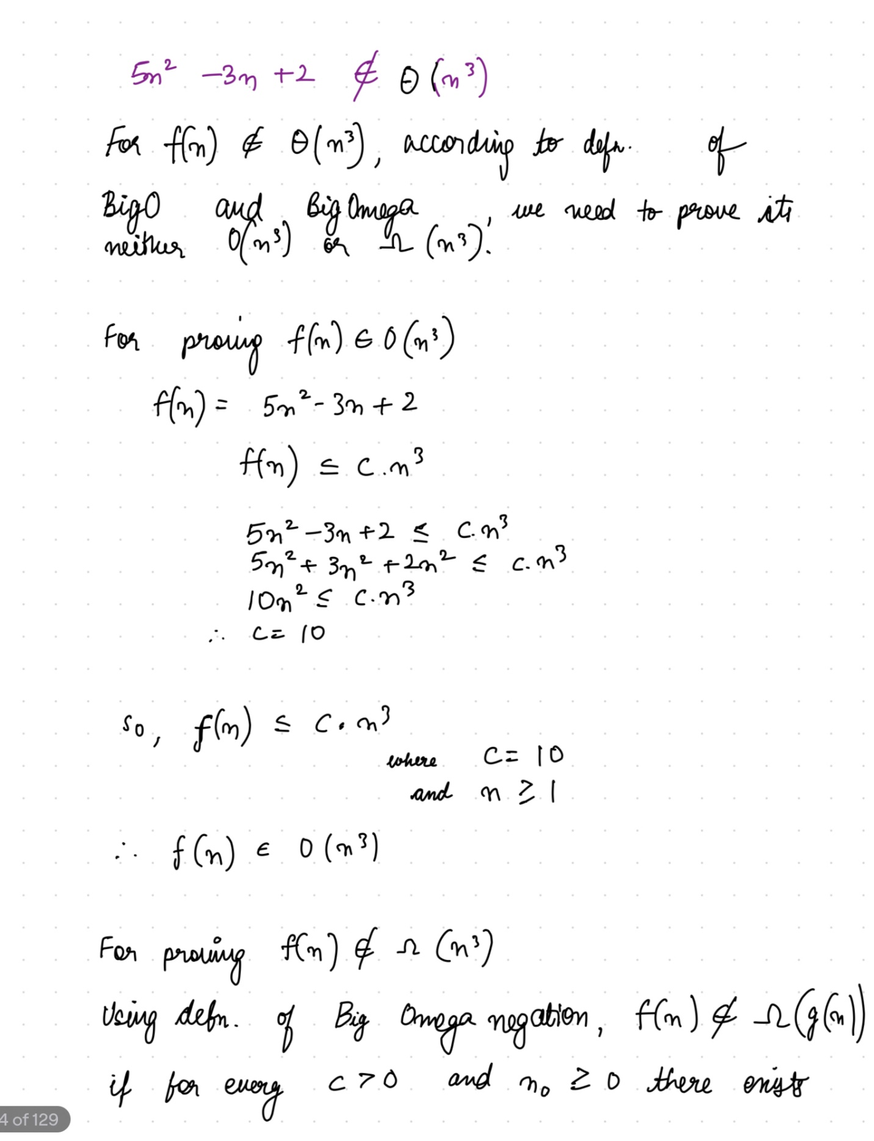
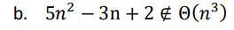
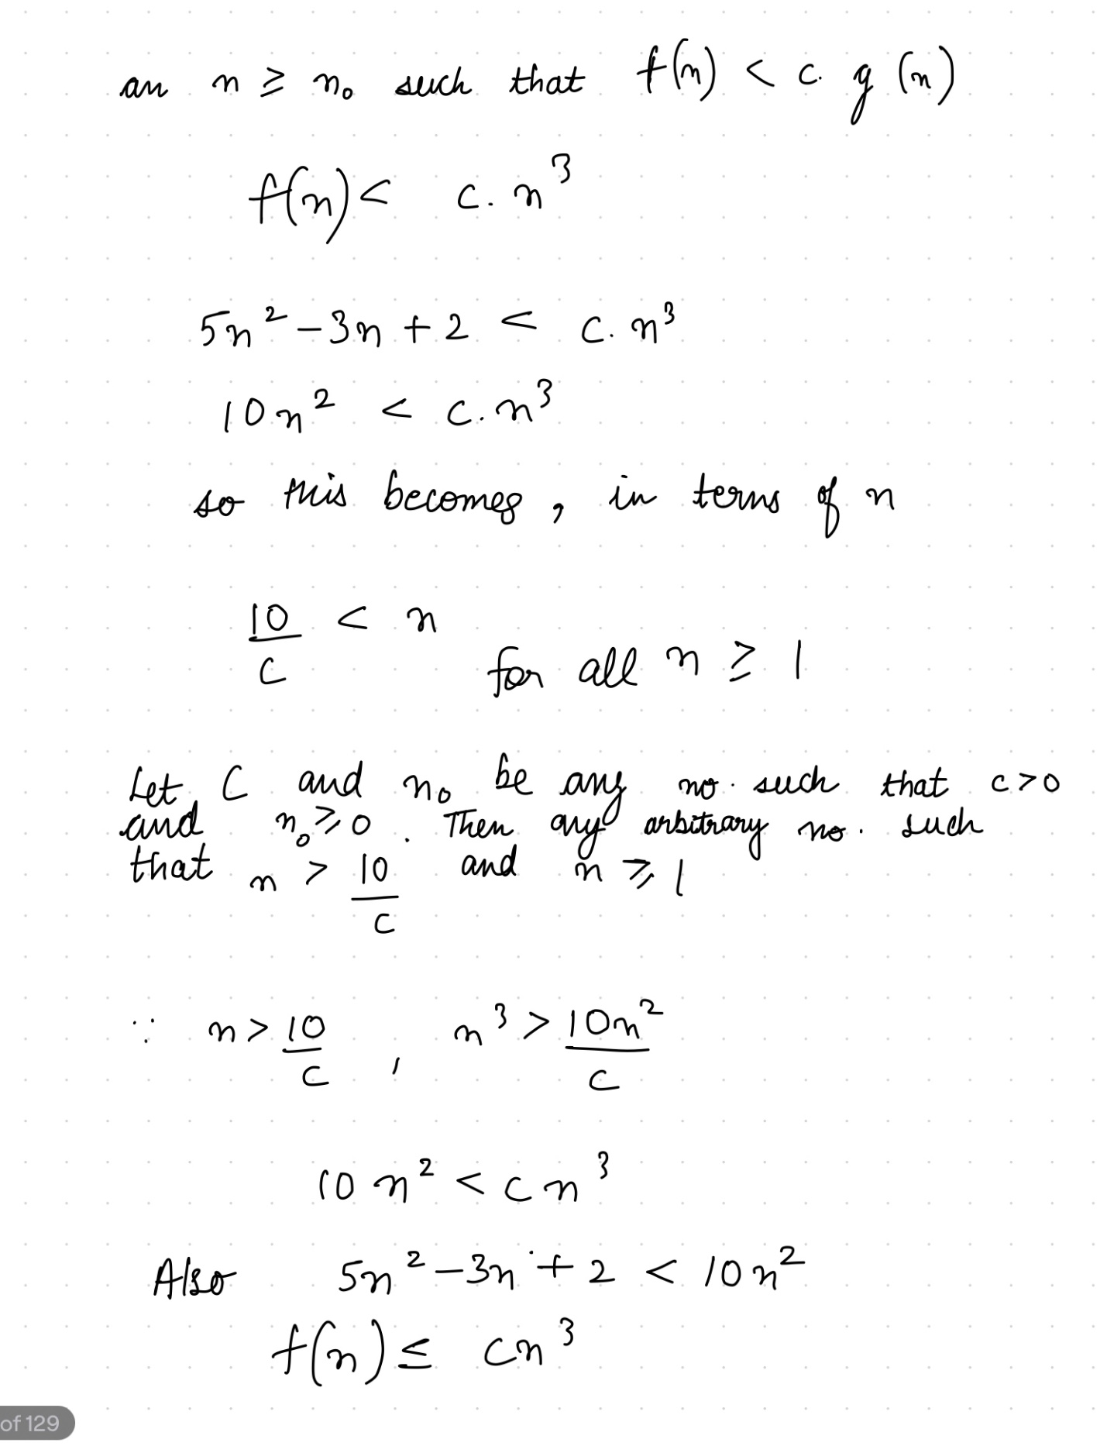

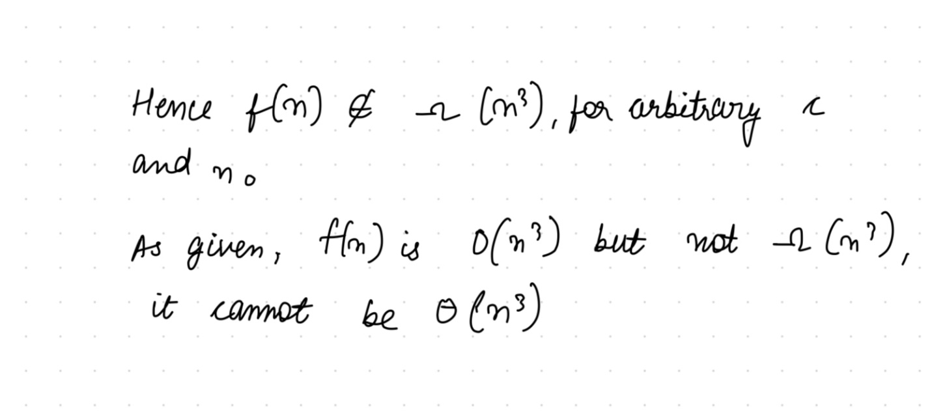

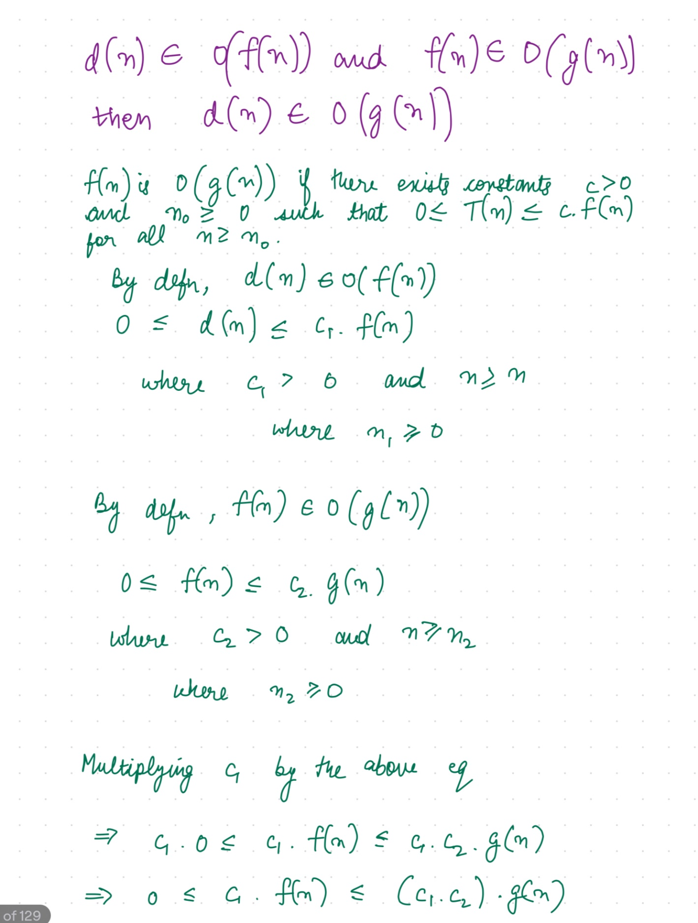
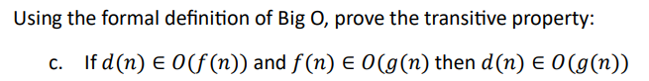
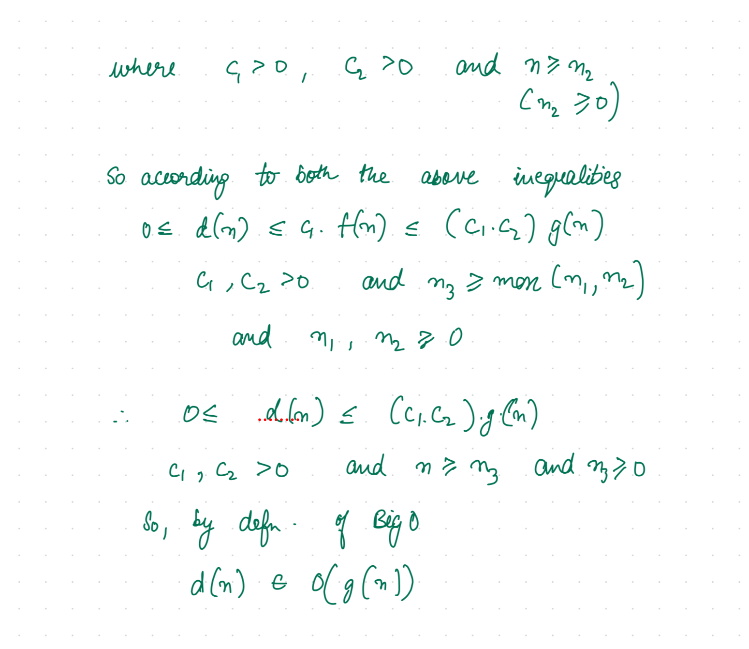

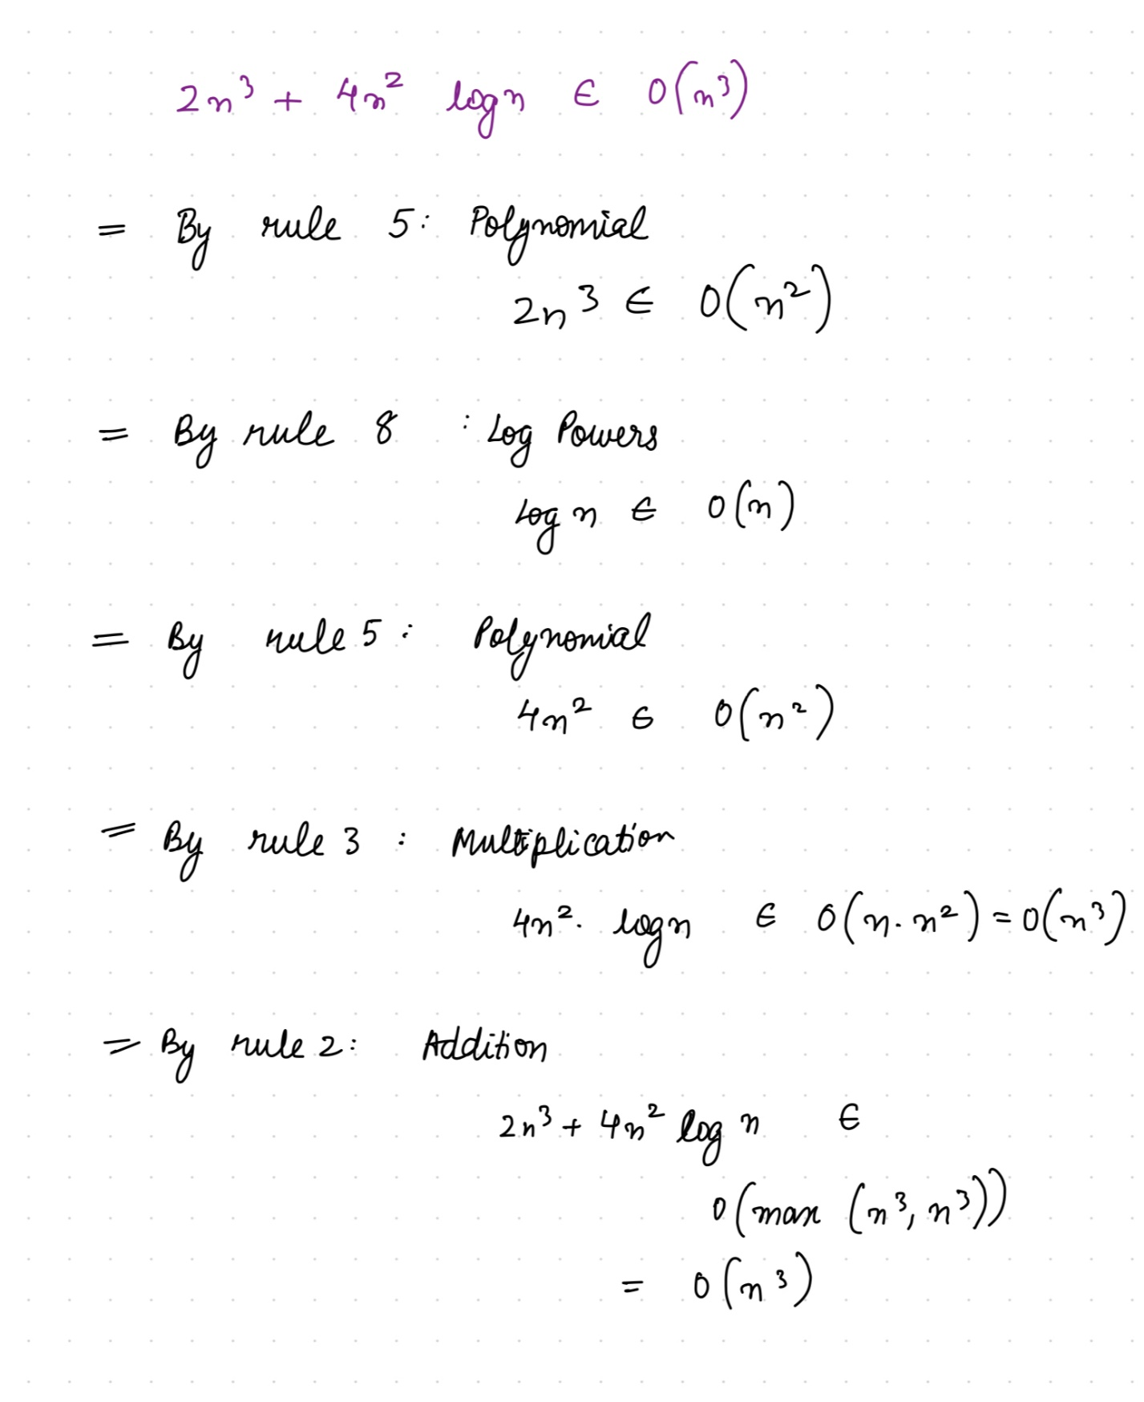
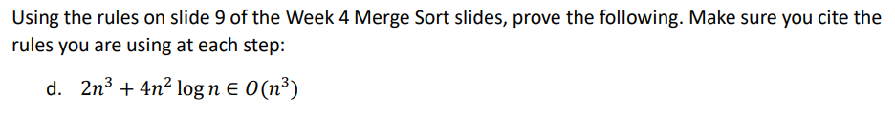
Question 2: Basic Sorting Write pseudocode for a linked list swap operation that accepts three parameters – a doubly linked list L, and two pointers a and b that point to Node elements inside the linked list. Change all the relevant previous and next links so that Nodes a and b swap places within the list. You may assume that Node b comes after Node a in the list, and that they are not the same Node. Make sure you cover all relevant special cases

function swapNodes(L, a, b):
# Handle edge cases where 'a' or 'b' is the head or tail of the list.
if a == L.head:
# If 'a' is the head, update the head to 'b'
L.head = b
if b == L.tail:
# If 'b' is the tail, update the tail to 'a'
L.tail = a

# Store previous and next nodes of 'a' and 'b'.
aPrevious = a.previous
bNext = b.next
aNext = a.next
bPrevious = b.previous

# Handle the case where 'a' and 'b' are adjacent.
if aNext == b:
aPrevious.next = b
b.previous = aPrevious
a.next = bNext
bNext.previous = a
a.previous = b
b.next = a
else:
# Handle the general case.
a.next = bNext
if bNext != NONE:
bNext.previous = a
a.previous = bPrevious
bPrevious.next = a
b.next = aNext
aNext.previous = b
b.previous = aPrevious
if aPrevious != NONE:
aPrevious.next = b

return
Question 3: Quicksort Even with a random shuffle, quicksort can get unlucky. Give 4 different size 5 arrays of integers that will cause quicksort to exhibit its worst-case running time of O(n^2). Each example should show a different relative ordering of the elements in the array, not just different numbers. For example [0, 10, 20, 5, 2] and [1, 4, 5, 3, 2] are not different examples because the relative order of the elements is the same. In each case, explain why this arrangement will lead to O(n^2) running time.

Example 1 (Descending Order): Array: [5, 4, 3, 2, 1]
When the array is sorted in descending order with different numbers, using the last element (1) as the pivot consistently results in unbalanced partitions. This is because all other elements are greater than the pivot, leading to a worst-case time complexity of O(n^2).
Example 2 (Ascending Order): Array: [-2, -1, 3, 4, 5]
The array is sorted in ascending order with different numbers. If we use the first element (-2) as the pivot, it still creates unbalanced partitions. This is because all other elements (ranging from -1 to 5) are greater than the pivot. Consequently, the partitioning step consistently produces partitions where one side contains all the elements, resulting in a worst-case time complexity of O(n^2).
Example 3 (Alternating Order): Array: [10, 30, 20, 50, 40]
With an alternating order of different numbers, selecting the first element (10) as the pivot also leads to unbalanced partitions. The varying distribution of numbers around the pivot results in an inefficient partitioning process and a worst-case time complexity of O(n^2).
Example 4 (All the Same Element): Array: [1, 1, 1, 1, 1]
When all elements are the same (in this case, all are 1), and any element is chosen as the pivot, it leads to unbalanced partitions every time. This is because every element in the array is equal, so one side of the partition will always be empty, and the other side will have all the elements. Consequently, the algorithm will make many recursive calls, as it effectively makes no progress towards sorting the array, resulting in a worst-case time complexity of O(n^2).

