
McMaster Faculty of Engineering
Hamilton, Ontario Canada
Innovate 2Z03
Assignment #2 – Recruiting for Interviews, Selecting Solutions and Prototyping Due Date: February 15, 2026
This assignment is a group assignment and one assignment should be submitted per group.
In this assignment your sprint team is tasked with reviewing the individual solution “sketches” done in assignment 1 and building a simple prototype (or façade of a prototype) to test with users.
The deliverables for assignment are as follows:
1) A list of the key attributes you are looking for in a potential interviewee (5 marks)
- Students in university (Possible exception for high school students)
- Someone enrolled in content heavy courses.
- Someone who regularly uses and prefers textbooks (both digital and physical)
- Someone enrolled in courses that need and assess heavily based on specific textbook content. (ie, courses that need students to have a textbook in order for them to do well).
- Students who have had past experience with lack of access both financially and physical to textbooks.
- Students who have bought or sold textbooks through second-hand or peer-to-peer sites (Facebook groups, online marketplaces, etc.).
- Students who have encountered confusion or uncertainty regarding the editions of the textbooks, what is necessary vs. what is optional, and what the instructor expects.
- Students who have tried to sell textbooks at the end of the course and have encountered problems.
2) A list of survey questions you would use to recruit potential interviewees to your customer interviews (10 marks)
- Can you walk me through how you usually get access to your textbooks for a course?
- Have you ever started a specific course without having the textbook right away? What happened?
- What makes it generally difficult for you to access a textbook when you need it most?
- Can you describe a time when not having access to a textbook affected your studying or grades?
- How do you decide whether a textbook is “worth getting” for a course?
- What alternatives do you use when you don’t have the textbook and how well do they work?
- What are your thoughts on sharing, renting/ borrowing textbooks? Is it more efficient and accessible for you?
- Do you prefer digital or physical textbooks?
- If textbook access was easier or cheaper, how would that change the way you study?
- What are the biggest challenges you currently face in getting access to textbooks for your courses?
More questions, based on theme:
Edition Accuracy
When purchasing a textbook, how do you verify that the edition of the book you are buying is the same as the one your instructor expects you to read?
Instructor Communication Gaps
Has there ever been a course where the textbook was included in the course outline but later turned out to be optional or rarely used? How did you discover this?
Platform Reliability
Have there been instances where you have committed to buying a textbook online but later discovered that it was no longer available on the website before making the purchase?
Transaction Safety
What measures do you take to ensure your safety when meeting someone to buy a textbook, and what are your concerns?
Hidden Costs
What costs do you factor into buying a textbook apart from the price of the book itself?
Search Inefficiency
What is the approximate amount of time you spend searching for a textbook on different websites before making a decision on where to buy it?
Resale Barriers
What barriers have prevented you from reselling a textbook after a course has ended?
System Improvement Insight
What information would have been helpful to know before buying a textbook to make a more confident decision?
3) Your annotated solution sketches from assignment 1 showing what the group liked about the solutions, any questions that came up during review, and what the members of the group voted for as the solution(s) to pursue (15 marks)
Annotations:
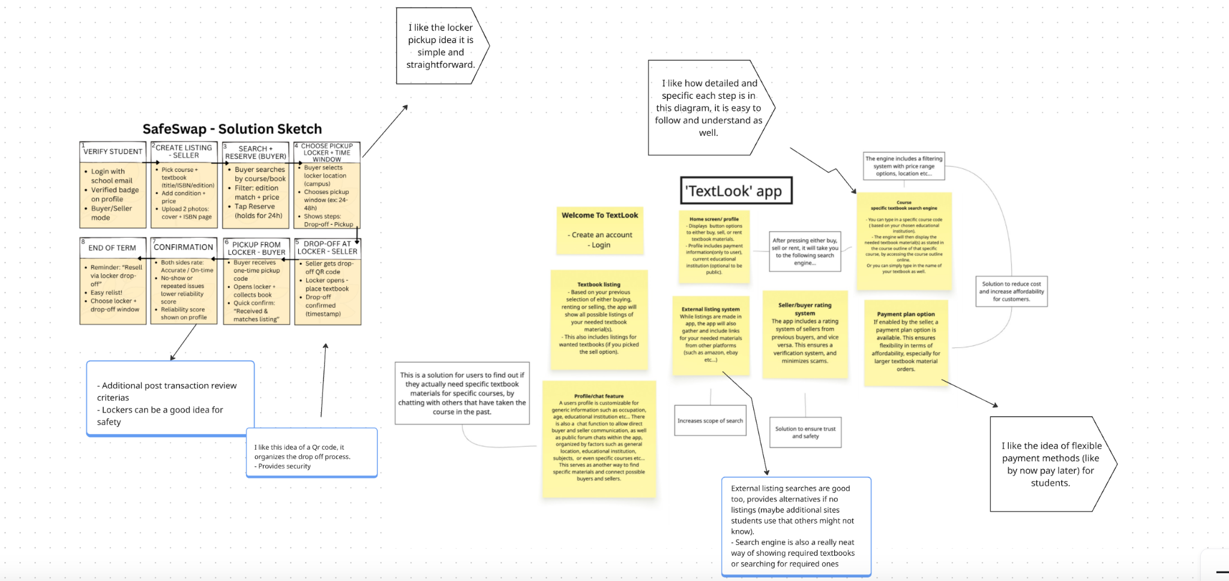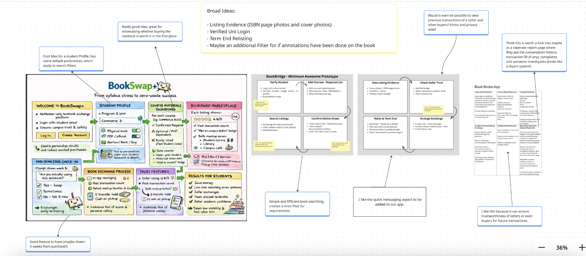
Below are the summaries of group members votes for certain features from each sketch, after our meeting session:
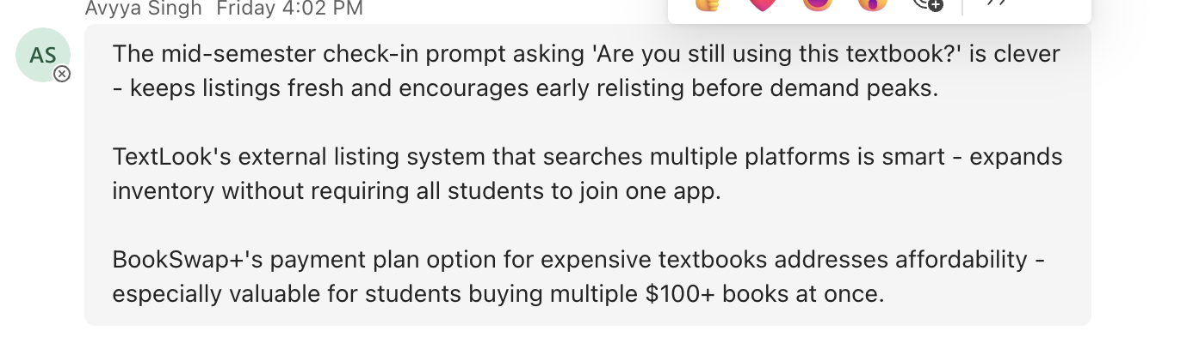
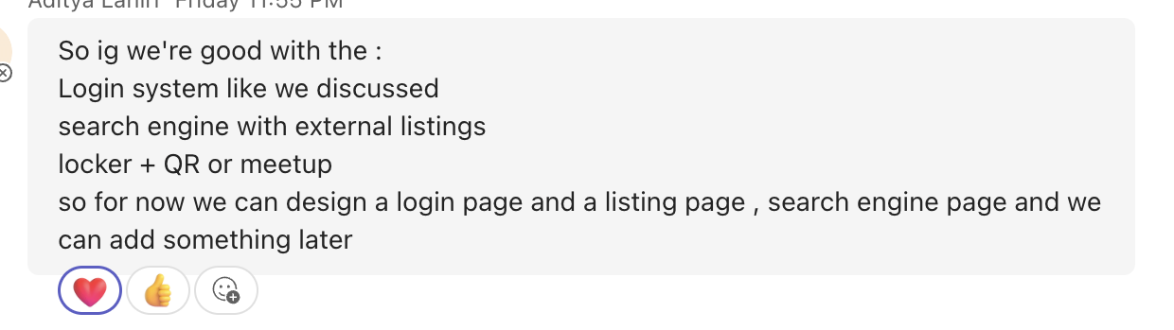
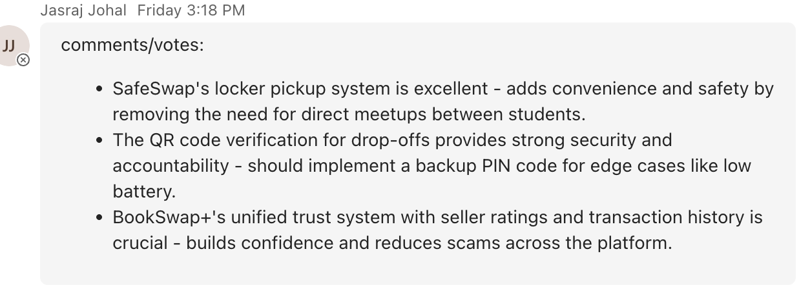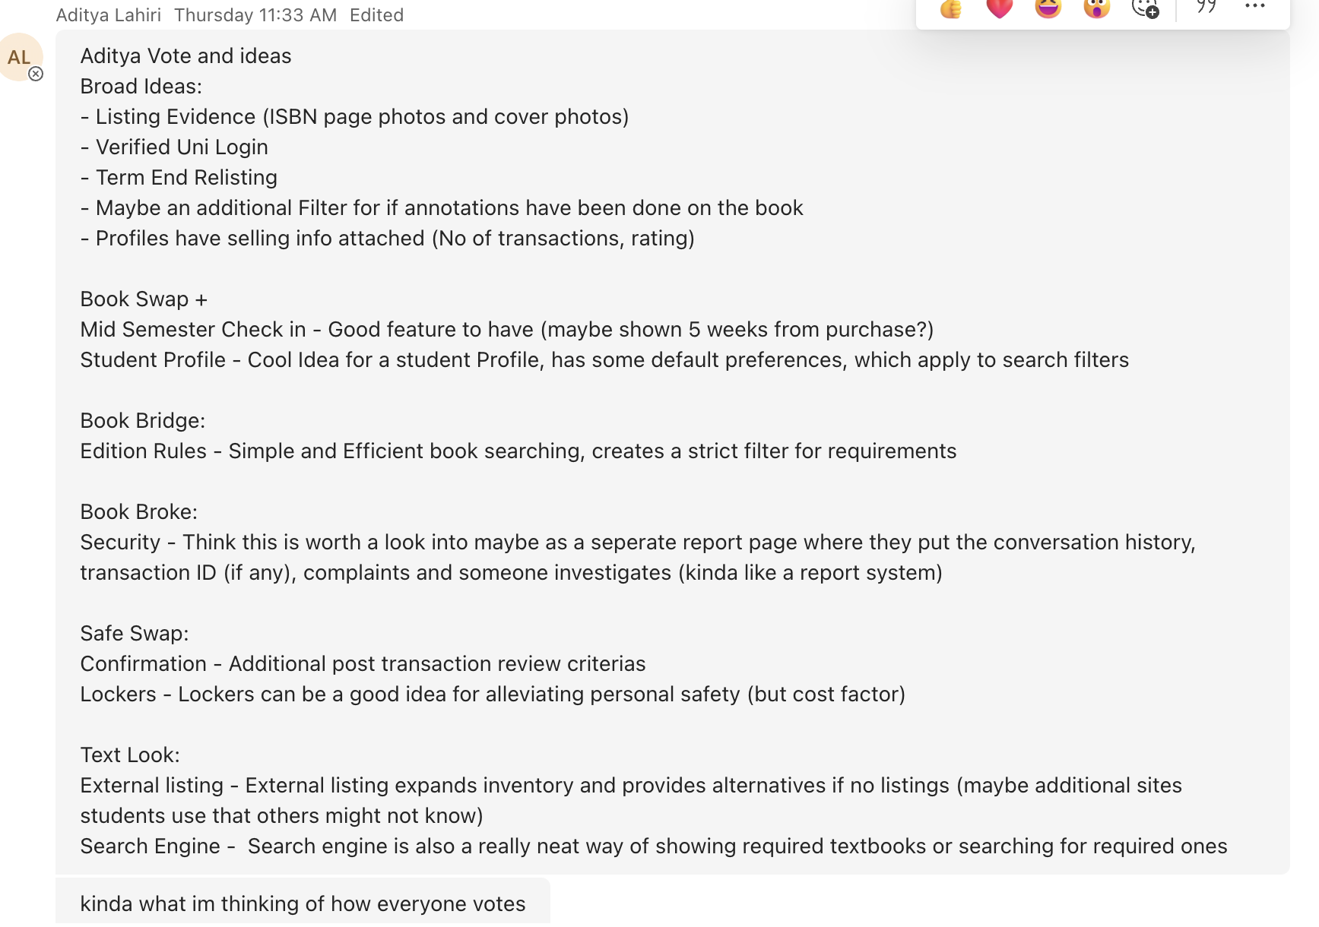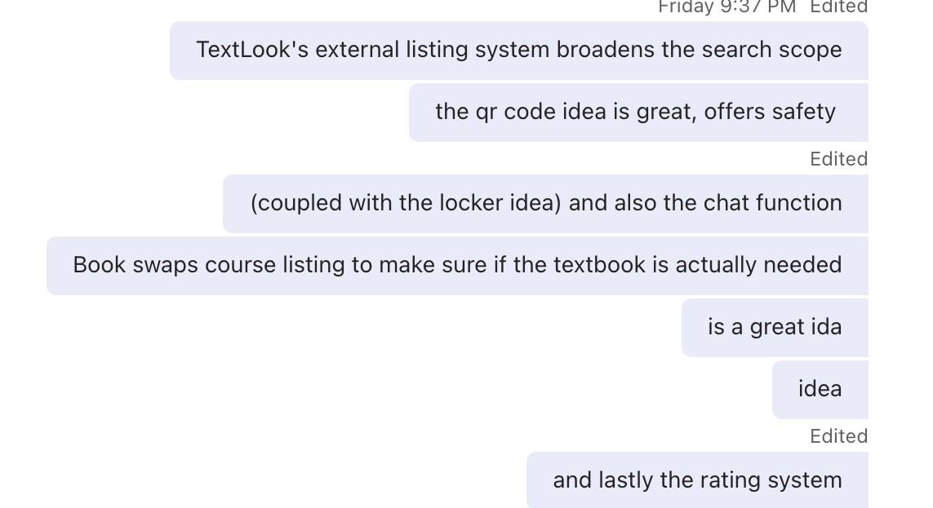

4) An explanation of what the Decider has decided to be the solution or solutions to pursue (10 marks)
Our group decided to not vote on one single sketch, but to instead select and compile different features and solutions we liked from every sketch, as a collective solution.
The Decider prioritized features that directly address the highest-friction points in the textbook acquisition journey - trust, availability, and safety. The platform will require university-based login authentication, ensuring all users are verified students and creating accountability that differentiates it from informal marketplaces.The solution includes a structured search system, allowing students to search by course code, textbook title, ISBN, or author name. Course-based search ensures alignment with required materials based on previous years course outlines, while flexible search options support broader discovery and edition verification. If on-platform inventory is limited, relevant external listings will be surfaced to expand available options.
The exchange process will be structured and secure, offering:
- On-campus meetups coordinated through in-app chat, or
- Secure locker pickup with QR code verification (with backup PIN functionality).
To reinforce trust, the platform will include seller profiles with transaction history and ratings, mandatory listing evidence (ISBN and cover photos), post-transaction reviews, and a structured reporting system linked to verified accounts. Supporting features include edition-specific filtering, annotation status filters, and a mid-semester check-in prompt to encourage relisting. Overall, the Decider has chosen features minimizing hassle, risk and uncertainty for students.
5) A storyboard that shows how the customer would engage with the potential solution during your customer interview (10 marks)
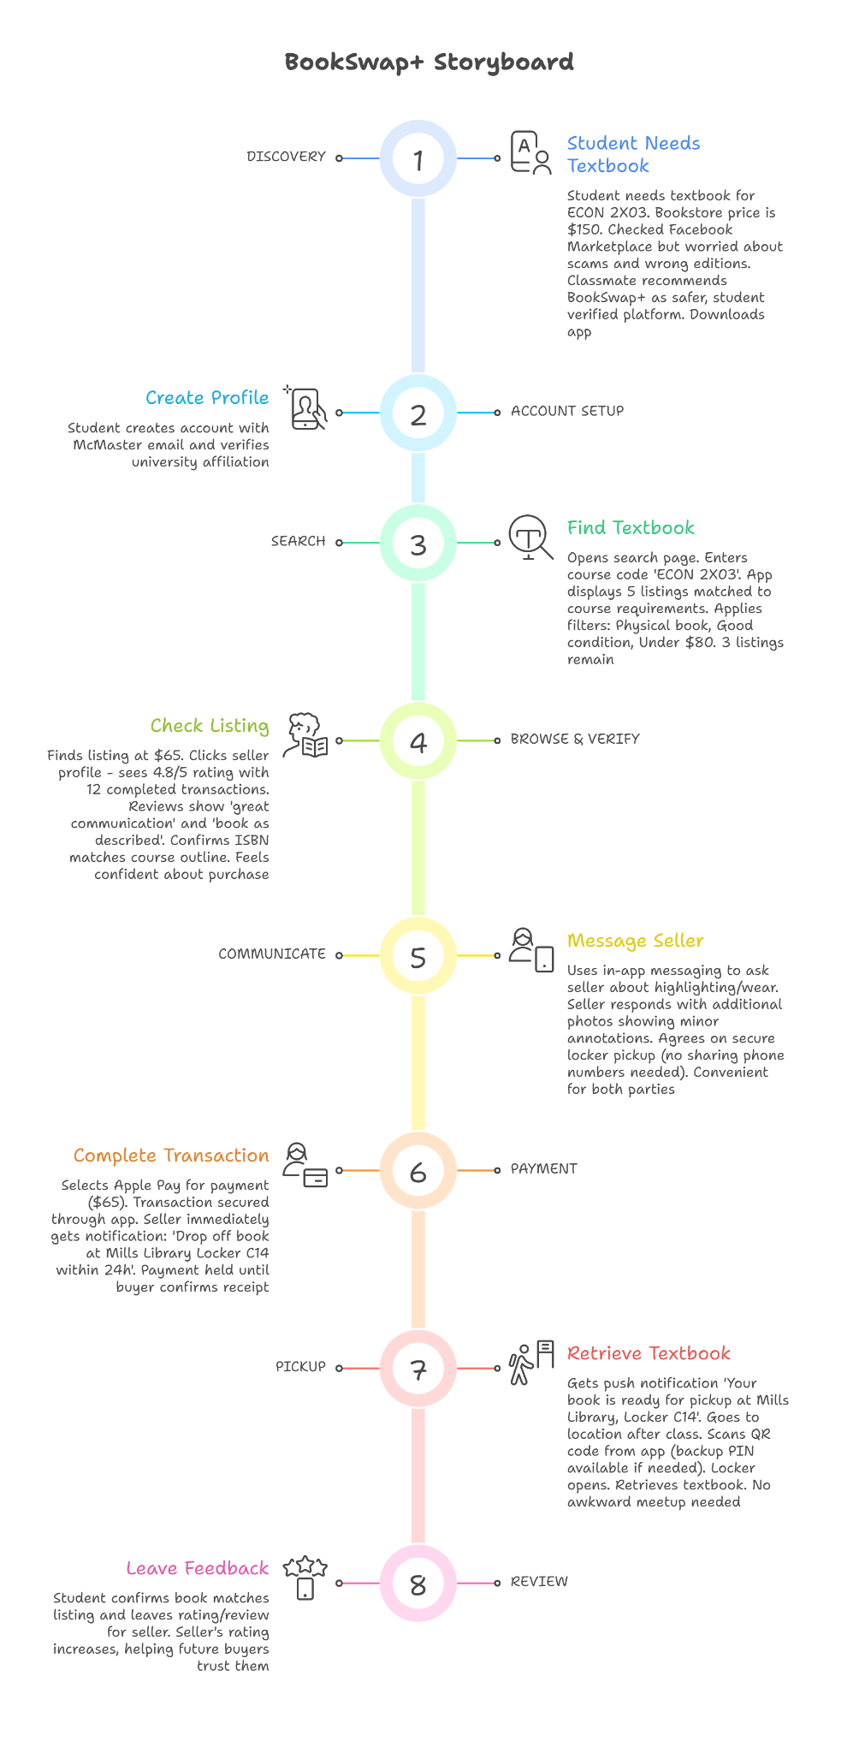

6) A prototype or façade that can be used in a customer interview to get the customer’s reaction to the solution (25 marks) *For full screen access
Organized in order of customer journey:
